XIAN-Black Sea- Chersonesos

Chersonesos Cited in Works by Ancient Authors

**A REVIEW OF THE HISTORIOGRAPHY OF CHERSONESOS  
According to G. D. Belov**

       In studying the history of Chersonesos one can use two types of sources: written and archaeological. The first is relatively limited in quantity and consists of works by Greek, Roman, Byzantine, Arab, and other writers. Besides this, some information about Chersonesos can be garnered from hagiographic sources, letters of contemporaries, Rus' chronicles, and treaties between Rus' princes and Byzantium.  
       Apart from a few cases, written sources supply fragmented data which describe only isolated moments from the history of Chersonesos. [Epigraphic monuments](http://www.chersonesos.org/?p=museum_coll_ep&l=eng) found during excavations compose a unique and rather extensive category of written sources.  
       The earliest information about Chersonesos dates to the second half of the 4th century BC and is found in the *Periplus* ("description of the sea") attributed to a Greek author, [Skilakes of Kariand](http://www.chersonesos.org/?p=history_sour1&l=eng). The *Periegesis* ("description of the Earth") of the late 2nd century BC attributed to [Skimnos of Chios](http://www.chersonesos.org/?p=history_sour2&l=eng) is the basic source of information for the founding of Chersonesos by Heraklea Pontica and Delos. However, this Periegesis was not actually written by Skimnos; it originates from earlier works, such as the historical geography by Ephorus and the geography by Dimitrios of Kallatis. The latter lived in the late 3rd century BC and had a good knowledge of the geography of the Pontus.  
       The geographer [Strabo](http://www.chersonesos.org/?p=history_sour4&l=eng), who lived in the early 1st century AD, composed the most detailed and complete description of Crimea. His Geography gives a detailed description of the history of Crimea during the Mithradatan period (end of the 2nd - 1st centuries BC). Despite the fact that Strabo supplied a great deal of information about Chersonesos and its environs, he himself had never been to Crimea and used works by other authors, like Dimitrios of Kallatis, as sources for his Geography.  
       Although later Greek authors briefly mention Chersonesos, the majority of them used works by their predecessors, and thus do not supply new data about Chersonesos. Among these authors are: a contemporary of the Flavius dynasty, Joseph Flavius; Memnos, who lived in the late 1st - early 2nd centuries; Flegon of Tralls, who lived during the reign of Adrian; Appian, a contemporary of Adrian and Antoninus; Ptolemy and Polyenus, contemporaries of Marcus Aurelius; and Stephen of Byzantium and Pseudo-Arius, authors of the 5th century.  
       Among Roman authors, [Pliny the Elder](http://www.chersonesos.org/?p=history_sour5&l=eng), Pomponius Mela, and Pompey Trog supply brief information about Chersonesos.  
       Byzantine authors provide significant information about the history of medieval Chersonesos (or Cherson, as it was called in medieval Byzantine sources, or Korsun' in Rus' literature). Procopius in his treatise On structures writes that during the reign of Justinian I new fortifications were built in Crimea, and the walls of Chersonesos were restored. In his Gotica the historian Jordanus writes about the barbarian population of Crimea, about the Hun tribes, who lived in the neighborhood of Cherson, and about that city's trade with Asia. Theophanus, Nicephorus, and Constantine Manassis give evidence for the events related to Justinian II's exile to Chersonesos and his later siege of the city. Pope Martin I, who was also exiled to Chersonesos, describes in his letters the economy of the city in the middle of the 7th century.  
       Byzantine Emperor Constantine Porphyrogenitus dedicates the entire 53rd chapter of his De *administrando imperio* to Chersonesos. He comprehensively describes the wars between Rome and the barbarians in Crimea and in the Balkans, and the active role of Chersonesos in these events. Constantine's story of Chersonesos suggests that there was probably an extremely patriotic local source behind its writing, which is why some of the author's data should be considered improbable and anecdotal. However, Constantine's advice to his son Romanus, which gives a contemporary description of the political and economic situation in Chersonesos of the mid 10th century, accounts of the city's trade contacts with Asia Minor, and its relations with local tribes and Byzantium itself are highly valuable.  
       There is a long list of sources for the early Christian period of Chersonesos. The Life of St. Clement tells the story of Pope Clement's life in exile in Chersonesos. The so-called "Italian legend" describes the circumstances surrounding the discovery of his relics. A Vatican librarian, Anastasius, wrote a letter based on the description of the transfer of St. Clement's relics provided by the bishop Mithrophanus, who was exiled to Chersonesos in the mid 9th century and witnessed the event. The Memory and Life of St. Cyril supplies information about the discovery of these relics, about Cyril and Methodius' visit to Chersonesos in the 860s, and Cyril's missionary activities among the Khazars.  
       The Lives of the Bishops of Cherson provides accounts of the first Christian missionaries who arrived in Chersonesos in the early 4th century.  
       Various sources from Rus' and elsewhere describe the Kyivan Rus' chapter in the history of Chersonesos. The Life of George of Amastrius contains the story of the Rus' invasions of coastal towns of Asia Minor. The Life of Stephen of Surozh tells about the Rus' prince Bravlin's attack on the southern coast of Crimea. Patriarch Photius, Rus' chronicles, and treaties between Rus' princes and Byzantium all give accounts of the Kyivan Rus' raids on Constantinople. The events related to Grand Prince Volodymyr's campaign against Chersonesos-Korsun' are described for the most part in Rus' sources: chronicles, the Life of Volodymyr, the Glory of Volodymyr, the Tale by Metropolitan Illarion and others. Foreign sources also contain some data, such as works by the Byzantine authors, Leo the Deacon and Michael Psellus, Cedrenus and Zonara, Armenian historian Asokhik, Arabian authors Al-Mekin, Ibn-al-Asir, and others.  
       Several monuments of Rus' literature are important sources for the later history of Chersonesos. The chronicle of 1066 relates how the "kotopan" (the kotopan or strategus was the commander appointed by the Byzantine emperor) poisoned the prince of Tmutarakan', Rostislav Vladimirovich. This source supplies information about Chersonesos' rebellion against Byzantium in 1073-1074. The Pateryk of the Kyivan Cave Monastery contains information about the trade of Rus' captives in Chersonesos. The Tale of Ihor's Regiment calls Korsun' one of "unknown" lands.  
       In the Legend of Miracles of Eugenius of Trebizond there is an account of Chersonesos' political dependence on the Trebizond empire in the early 13th century, and of the Turks pillaging Chersonesos and the Crimean coast.  
       We learn about the foreign relations of Chersonesos and the unrest which unsettles the city circa 1240 from Bishop Theodore's "Alanic epistle."  
       Thirteenth- and fourteenth-century Chersonesos is briefly mentioned in the works of the Arab writers Idrisi, Ibn-al-Asir, and Ismail Abul-Feda, as well as by the French ambassador William de Rubruquis. The latter saw a monastery on an island near Chersonesos as he was traveling by sea on his way to the Mongol khan in 1253. Documents of the patriarchy of Constantinople of the 14th century contain some material about the ordeals of the metropolitanate of Chersonesos and its metropolitan's conflicts with other metropolitans.  
       In the 14th-15th centuries information about Chersonesos becomes more and more sparse. Metropolitans of Chersonesos are mentioned more often than the town itself, which by this time finally lost its important commercial role.  
       Despite the abovementioned facts, the Italian travelers of the 14th-15th centuries continued to register Chersonesos on their maps, as is evidenced in the map of Visconti, the Catalan map of 1375, maps of Benincasa of 1476 and 1480, Barbaro and others. During this period the name of Chersonesos becomes completely distorted, being variably called Cersona, Gerizonda, Sarsono and Zurzona. The Turks called Chersonesos Sari-Kermen, that is, "yellow fortress."  
       Taking into account that on the threshold of the 14th and 15th centuries Chersonesos was burnt and destroyed, one can hypothesize that descriptions of it dating to the 15th and 16th centuries were related not to the town itself, but to its [ruins](http://www.chersonesos.org/?p=excav_hist&l=eng).

Pre-colonization period

• [The Geography of the Heraklean Peninsula](http://www.chersonesos.org/?p=history_pre&l=eng" \l "1%231)

• [Evidence for the Prehistoric Settlement of this Territory](http://www.chersonesos.org/?p=history_pre&l=eng" \l "2%232)

• [Archaeological investigations of the Heraklean Peninsula](http://www.chersonesos.org/?p=history_pre&l=eng" \l "3%233)

• [Archaeological Study of Pre-Colonization Sites](http://www.chersonesos.org/?p=history_pre&l=eng" \l "4%234)

• [Map of Archaeological Sites of the Pre-Colonization Period](http://www.chersonesos.org/?p=history_pre&l=eng" \l "5%235)

• [Catalogue of Archaeological Sites of the Pre-Colonization Period](http://www.chersonesos.org/?p=history_pre&l=eng" \l "6%236)

**THE GEOGRAPHY OF THE HERAKLEAN PENINSULA**

    The Heraklean, or Trachean, Peninsula forms a triangular projection on the southwestern edge of the Crimean peninsula. The cape of Chersonesos (called Fanar on old maps) lies at the vertex of this triangle, and the straight line between upper Sevastopol Bay (together with North and Large Bays) and upper Balaklava Bay constitutes its base. This geographic zoning appears in the ancient period. The Greek geographer and historian [Strabo](http://www.chersonesos.org/?p=history_sour&l=eng) (circa 64/63 BC - circa AD 20) referred to the Crimean peninsula as Tauric or Scythian Chersonesos, that is, the peninsula of the Taurians, or the Scythians (from the names of peoples living there). At times he also called Crimea - Chersonesos Major to differentiate it from another Tauric Chersonesos (or Chersonesos Minor) located on this peninsula, namely, what has been termed the Heraklean Peninsula since the 19th century [Strabo, VII, IV, 1-2]. The isthmus which connects Chersonesos Major and Minor is located between Symbolon Limen harbor (modern Balaklava Bay) and Ktenuntos harbor (modern Sevastopol Bay). There was a colony founded by settlers from Heraklea Pontica (in Asia Minor) on Chersonesos Minor, a city that was also called Tauric Chersonesos [Strabo, VII, IV, 2]. Crimea, or Chersonesos Major, covers an area of about 26,000 square kilometers, while the area of Chersonesos Minor (i.e. the Heraklean Peninsula) measures approximately 126 square kilometers.  
    From the point of view of Strabo and other Greek authors, Chersonesos Minor was remarkable only because of the existence there of a Greek city called Tauric Chersonesos. Citizens from Delos, expatriated from their island by the Athenians, participated in the founding of Chersonesos together with the Herakleans. It is supposed that the citizens of Delos were expatriated twice, in 528 BC and 422/21 BC, which is why the foundation of Chersonesos is dated either to 528 BC or 422/21 BC. The majority of scholars consider the latter date to be more convincing.  
    The results of archaeological excavations suggest that Chersonesos Minor, or the Heraklean Peninsula, was developed by Greek colonists and became the agricultural territory (chora) of the city of Chersonesos by the last quarter of the 4th century BC. The colonists divided about 10 square kilometers of the chora into plots.

**EVIDENCE FOR THE PREHISTORIC SETTLEMENT OF THIS TERRITORY** [[Top](http://www.chersonesos.org/?p=history_pre&l=eng" \l "top%23top)]

    The large-scale agricultural development of the ancient period and the construction of modern Sevastopol considerably reduced any traces of life which preceded the foundation of Chersonesos and the colonization of its outlying areas. From time to time these traces are recovered by finds of artifacts from the pre-colonization period made during excavations in Chersonesos and the ancient sites of its [chora](http://www.chersonesos.org/?p=chora&l=eng); however, for the most part they have not attracted the attention of scholars. Indeed, the only hypothesis scholars are willing to make on the relative lack of information is that this territory was populated from extreme antiquity. Scholars have concentrated mainly on ancient and medieval Chersonesos and a group of sites related to it.

**ARCHAEOLOGICAL INVESTIGATIONS OF THE HERAKLEAN PENINSULA** [[Top](http://www.chersonesos.org/?p=history_pre&l=eng" \l "top%23top)]

    In 1922-1924 Lev Solovev, an employee of the museum of Chersonesos, started the purposeful search for sites of the pre-colonization period on the Heraklean Peninsula and neighboring areas. He found the sites of many settlements and cemeteries of the Bronze and Early Iron age that are well-known today. Unfortunately, his archaeological investigations have never been continued and developed. His results are still unpublished and unknown to the majority of scholars. In the early 1950s Stanislav Strzheletskiy collected and systematized data from libraries and archives and as a result he attributed more than twenty sites on the Heraklean Peninsula with traces of the Bronze Age or Early Iron Age settlements or individual artifacts, three to four groups of megalithic stone burial constructions (cist burials), and at least ten groups of kurgans. At the same time he supervised the large-scale excavations of houses and household pits of the early 1st millennium BC in the Uch-Bash settlement near modern Inkerman, and a cemetery of megaliths (cist burials), which was probably related to this settlement. In the early 1970s Strzheletskiy's investigations were continued by the Sevastopol archaeological expedition of the museum of Chersonesos headed by Oleg Savelya. Consequently, a group of Bronze and Early Iron Ages sites were found to be located in modern building zones and developed land plots in Sevastopol. Several sites were excavated.  
    The results of the aforementioned investigations provide us with a perforated outline of the history of Tauric Chersonesos (i.e. the Heraklean Peninsula) and its adjoining area in the pre-colonization and early-colonization periods.

**ARCHAEOLOGICAL STUDY OF PRE-COLONIZATION SITES** [[Top](http://www.chersonesos.org/?p=history_pre&l=eng" \l "top%23top)]

    Two kurgans of the Kemi-Oba and Pit Grave archaeological cultures signify that the Heraklean Peninsula was populated in the 3rd - early 2nd millenia BC. There is no reliable data for the Late Stone Age (Mesolithic and Neolithic); however, no specialists dealing with the Stone Age have studied the area. There are sites with apparent Mesolithic and Neolithic traces situated near the Heraklean Peninsula, and it is possible that the Stone Age sites of Tauric Chersonesos are merely waiting to be uncovered by scholars.  
    From the earlier Bronze Age there are eight settlements of the Catacomb archaeological culture. They are located on the terraces of hollows and gullies, in places with fertile and water-bearing soils. A cemetery of the late stage of the Catacomb culture, many features of which are similar to the sites of the Kamenka - Liventsy group, has been excavated near the Heraklean Peninsula. However, in general terms there has been no purposeful and large-scale study conducted according to modern scholarly standards of these sites and sites of the Frame Grave culture (or culture of log cabin burials) (Late Bronze Age) located on Chersonesos Minor (the Heraklean Peninsula).  
    In areas near the Heraklean Peninsula there are numerous settlements of the Kizil-Koba culture (Early Iron Age): in the lower valleys of Belbek and Chorna rivers, especially in the region of Inkerman. On the Heraklean Peninsula itself there are more than twenty sites bearing features of the Kizil-Koba settlements. Many scholars tie the bearers of the Kizil-Koba culture to the Taurians of ancient myths and descriptions.  
    These settlements were located on slopes of gullies and hollows that were protected from the wind, and near fertile and water-bearing soils of floodlands and thalwegs, sometimes on former settlements of the Bronze Age. The sizes and configurations of these settlements depended mainly on the topography of the area.  
    No evidence exists for the regular planning of these settlements. Semi-pit dwellings, pit-dwellings, and fragile ground constructions have not been investigated adequately. Traces of settlements consist for the most part of household pits, which were used for short periods and then filled with refuse. The results of archaeological studies indicate that the main occupations of the bearers of this culture were farming and tending animals. It is possible that at least some of the household pits were used as sacrificial places. In several cases, including those on the Heraklean Peninsula, there were dog and even human burials inside these pits. The latest burials date to the 5th-4th centuries BC. (Herodotus' story of the Taurian ritual of human sacrifice is unwittingly brought to mind.)  
    In recent years fragments of Greek fine ware and amphorae of the 5th-4th centuries BC have been discovered in infills of household pits on the Kizil-Koba settlements located on the territory of the later Greek chora of Chersonesos (divided into land plots by the last quarter of the 4th century BC). Thus emerges the first evidence for the co-existence of Greek Chersonesos with the neighboring Taurians - contacts which were established in the first stages of the life of the city. A line of new barbarian settlements appeared along the frontiers of the Heraklean Peninsula approximately in the middle of the 4th century BC. From the point of view of topography these settlements were related to the system of the Greek land plots of Chersonesos. Thus it is possible to hypothesize that the barbarian settlements and their adjacent plots made up part of the structure of the chora of Chersonesos in the 4th and 3rd centuries BC.  
    Archaeological data suggest that the situation in Tauric Chersonesos considerably differs from that in another areas of the northern Black Sea region that underwent Greek colonization.

**MAP OF ARCHAEOLOGICAL SITES OF THE PRE-COLONIZATION PERIOD** [[Top](http://www.chersonesos.org/?p=history_pre&l=eng" \l "top%23top)]  
  
[Under construction]

**CATALOGUE OF ARCHAEOLOGICAL SITES OF THE PRE-COLONIZATION PERIOD** [[Top](http://www.chersonesos.org/?p=history_pre&l=eng" \l "top%23top)]  
  
[Under construction]

© O. Ya. Savelya, 2000.

# Chersonesos

### From Wikipedia, the free encyclopedia

### 

### 

### 

### 

### 

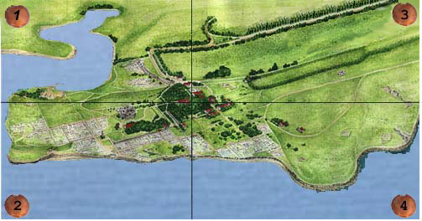

|  |  |  |  |  |  |  |  |  |  |  |  |
| --- | --- | --- | --- | --- | --- | --- | --- | --- | --- | --- | --- |
| Tower of Zeno     |  |  |  | | --- | --- | --- | | *Inscription in Honor of the Emperor Zeno* |  | This is the most important tower of the southeastern zone of defense, erected on the southern flank of the port section. It is called the Tower of Zeno after references in an [inscription](http://www.chersonesos.org/?p=museum_coll_ep2&l=eng) found in the tower detailing the reconstruction of the city walls during the reign of the emperor Zeno in the 5th century. |          The earliest core of this tower measures about 8 meters in diameter. It was constructed in the 2nd century BC during a time when Chersonesos waged a series of wars on the Scythians. The builders of the tower used funeral monuments - stelai - from the city necropolis in the masonry. Polychrome paintings from the 4th and 3rd centuries BC decorate some of these funeral markers. .   |  |  |  |  |  | | --- | --- | --- | --- | --- | |  |  |  |  |  |          Two centuries later, this heavily damaged tower was strengthened with an additional ring of masonry. A second ring was built in the 5th and 6th centuries, possibly during the reign of the emperor Zeno. The lower rows of the masonry facade dating to this period have been preserved, as is visible in the [peribolos](http://www.chersonesos.org/?p=ct_map17&l=eng) at the 19th curtain.  *Schematic plan of Tower of Zeno. Building periods from the 2nd century BC to the 10th century AD are indicated by different hatching.*         In the 9th and 10th centuries the tower was rebuilt once more and its diameter increased to 23 meters. A guardhouse was constructed inside the tower. From the tower one can reach a platform above the gates to the peribolos.   |  |  |  | | --- | --- | --- | |  |  |  |   *Tower of Zeno. Reconstructions.* |

Citadel

       In the 2nd century BC the territory of the port at Chersonesos was enlarged to include a part of the shore southward from the 16th tower. A new wall constructed to protect this area ended with tower no. 17, also called the [Tower of Zeno](http://www.chersonesos.org/?p=ct_map11&l=eng). The old defensive line, now inside the city, was also preserved. Thus, the new area was surrounded with walls and towers from every side. Scholars use an artificial term - citadel - to indicate this new structure. In the first centuries AD Roman legionnaires were garrisoned here. They could move to the citadel from the [peribolos](http://www.chersonesos.org/?p=ct_map17&l=eng) through an arch-vaulted wicket. Above this construction exists the threshold of a medieval wicket dating to the 9th-10th centuries. If one looks at the masonry of [the 16th tower](http://www.chersonesos.org/?p=ct_map17&l=eng) from the citadel, one can see the architectural details of buildings of the 3rd and 2nd centuries BC in it.

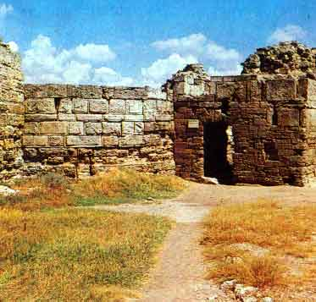  
*The entrance to the citadel from the peribolos*

       Narrow streets with gutters, water pipes, and buildings from the 2nd to the 4th centuries AD have been excavated inside the citadel. To the south of the defensive wall and extending to the sea was a monumental building with three rooms covering an area of more than 600 m2. The middle room was the largest; narrow side rooms were divided into smaller chambers with entrances into the central hall. This building is supposed to be the Roman *praitorion*, that is, the residence of the military commander.

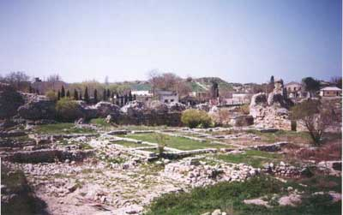  
*The northwestern view of the citadel*

### Behind this structure were Roman *termae* (baths) from the 2nd-4th centuries, five rooms of which are visible today. There were ovens for heating air and water in three of them. Hot air passed through pipes under the floor of the rooms, thus heating them to the necessary degree. Investigations of the termae are still underway.

Arched niches church

       A medieval residential block was excavated at the [city gates](http://www.chersonesos.org/?p=ct_map15&l=eng) of the 4th-3rd centuries BC. Under the medieval houses, at a depth of two to three meters, lay the remains of earlier buildings. This block contained two-storied houses, the rooms of which were situated around enclosed courtyards. The walls of the houses were made of rubble fastened with mud. A system of gutters connected the houses with the wide streets.

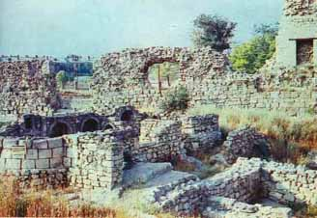  
*The arched niches church*

       In the 11th century or somewhat later two ancient blocks were united into one, a square was built in the middle of the new configuration, and a small church was erected in the middle of the square. Graves were fitted into the walls of the church, and arched niches were arranged above these graves to provide light into the building. The entrance to the church led from the square at the northern side of the building. A transverse street led to this area and connected the block with the downtown district. The arched niches church was demolished in the 13th or 14th century.

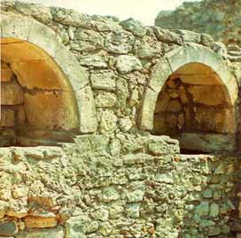  
*The arched niches*

City Gates

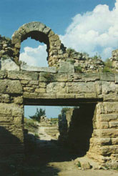  
*The Gates. View from the peribolos*

       These ancient gates were made in the thickness of the defensive wall in the 4th-3rd centuries BC. The gates are 3.8 meters wide and 8.4 meters long. The length of the gates was enlarged by means of side *pylons*, special projections perpendicular to the defensive wall. On the southern pylon one can see steps leading to the upper platform of the pylon and from there to the wall.

|  |  |  |
| --- | --- | --- |
| *The southern pylon and steps of the gates* |  | There is a hole for the beam locking the ranges of the gates in the same pylon. At the very entrance to the tower on each side of the wall there is a vertical groove for raising and pulling down a metal grate (*cataract*). The space between the cataract and the ranges of the gates could have been filled up with stones and earth, if necessary. In the 1st century AD the gates were blocked up, and the entrance to the city moved to the west from the [theater](http://www.chersonesos.org/?p=ct_map31&l=eng). |

       The wicket above the gates dates to the medieval period (9th-10th centuries). It was built when the ancient wall at this site was deep in the ground. From that moment, builders used the ancient wall as a foundation for medieval fortifications.  
       This part of the ancient walls was excavated in 1899. In 1902 it was visited by Emperor Nicholas II and Alexandra Fedorovna. The imperial couple was guided by [K. K. Kosciuszko-Valuzhinich](http://www.chersonesos.org/?p=excav_schol_prs_in2&l=eng).

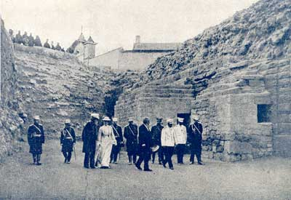

*"... Their Imperial Majesties were pleased to hear detailed explanations graciously, and were pleased to stay at the gates for most of the time..."*

From K. K. Kosciuszko-Valuzhinich's memoirs.

Crypts

       In the [peribolos](http://www.chersonesos.org/?p=ct_map17&l=eng), to the left of the city gates, there are two crypts dating to the first centuries AD. They were built alongside the defensive wall. From inside each construction resembles a house with a gable roof. Along the perimeter of its walls were niches where urns containing buried remains were placed.

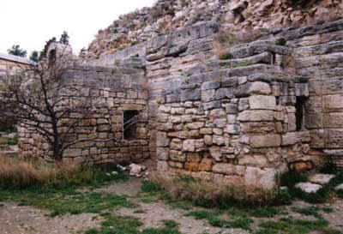  
*Crypts at the defensive wall. Modern view.*

       In the same area at the defensive wall lay a family grave from the 4th and 3rd centuries BC. Six bronze and black-lacquered ceramic urns were found inside this T-shaped grave.

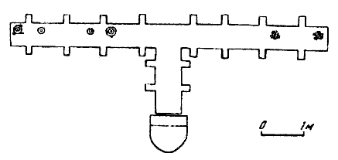  
*Plan of the T-shaped grave.*

       An inscription reading "a prize from the celebration of Anakios" has been preserved on one urn. This prize was received by the winner of sporting competitions held near Athens. A patron of the city walls of Chersonesos was probably buried in this crypt because it was contemporary with the construction of the walls. Two urns contained magnificent samples of ancient fine arts, and rich gold decorations: earrings, necklaces, bracelets. It was precisely these early-20th century finds which resulted in the nickname then given to Chersonesos - "Russian Troy." Consequently, the budget for excavations increased threefold.

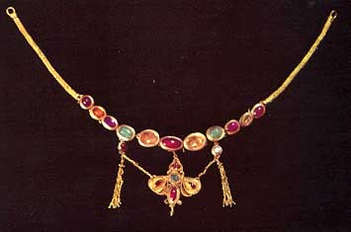  
*Necklace of the 1st - 2nd centuries AD. Found by K. K. Kosciuszko-Valuzhinich.*

       Russian Emperor Nicholas II visited the ruins of Chersonesos more than once. A photograph of the czar and his retinue was taken during their visit to one of the crypts at the defensive wall, but publication of this picture was prohibited at the time because the sovereign was captured bending as he exited one of the crypts.

### *Russian Emperor Nicholas II viewing the Chersonesan crypts*

The Church of Saint Volodymyr

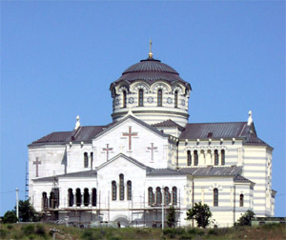

### The Church of St. Volodymyr was built on the site of a medieval cruciform church in the mid-19th century. The church is devoted to Kyivan Prince Volodymyr, who, according to the Rus Chronicle, was baptized in Chersonesos (Korsun'). Academician F. I. Chagin and architect D. I. Grimm, architects of the church, designed this two-story building with one chapel on each floor. The chapel of the Nativity of the Mother of God of Korsun' is located on the ground floor; St. Volodymyr chapel is on the first floor.       The remains of the cruciform church where the prince of Rus' was initially supposed to have been baptized are preserved on the ground floor of the modern church. The Church of St. Volodymyr was destroyed in the war years of 1941-1945 and now is under the restoration.       A survey of the history of the monastery of St. Volodymyr located at Chersonesos in the 19th and early 20th century has been published by [I. A. Antonova](http://www.chersonesos.org/?p=excav_schol_prs_in4&l=eng) in *Bogi Tavridy. Istoriya religiy narodov Kryma* (*Gods of Taurida. A History of Religions of the Peoples of Crimea*), 138-158 (Sevastopol, 1997). You can read a fragment of this survey dealing with the building of the church in Chersonesos on [this page](http://www.chersonesos.org/?p=ct_map21_1&l=eng). The information of the life of the church today and its reconstruction is on the page entitled This day.

Ancient Square

     A city square was located approximately in the central part of the [main street](http://www.chersonesos.org/?p=ct_map23&l=eng) in ancient Chersonesos. The Chersonesites laid the foundation of this square during the initial planning of the city. It continued to be the central square even after the territory of the city was widened. Considering the archaeological finds that have been discovered in this area one can assume that sacred objects and structures, such as statues of deities, inscriptions, decrees, altars, and temples were situated here in antiquity. Perhaps the most important monument of Chersonesos, the inscribed [oath](http://www.chersonesos.org/?p=museum_coll_ep3&l=eng), taken by young men who came of age, was excavated in the main square. Inscriptions on marble stelai reveal that here stood temples dedicated to Dionysos, Athena, Aphrodite. The main temple of Chersonesos devoted to its patroness, the Maiden, was probably located in the main square of the city.

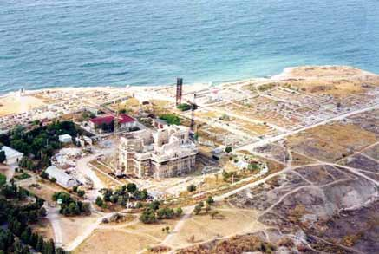  
*An Ancient Square from the air*

     With the advent of Christianity all cult buildings of the ancient period were either renovated or destroyed. Consequently, the square acquired a new outer appearance in the 9th and 10th centuries. Seven churches were erected; the remains of two of these can be viewed to the south of the modern [Church of St. Volodymyr](http://www.chersonesos.org/?p=ct_map21&l=eng). One is a basilica of the 6th (?) century with a preserved sanctuary and a nave with a fragmentary marble floor. Only the apse remains of the other - a cruci-domed church dating to the 9th or 10th centuries.

### In the mid-19th century construction of the Church of St. Volodymyr prevented any further investigation of the main square. Today the presence of the church hinders one from imagining that here the main square of the ancient city was once located.

|  |  |  |  |  |
| --- | --- | --- | --- | --- |
| Main Street   |  |  |  |  | | --- | --- | --- | --- | | *The Main street. Modern veiw.* |  | The main street of Chersonesos crosses the city at a southwest-northeast axis and is 900 meters long (uncovered so far) and 6.5 meters wide. On both sides of the street there were 14 blocks of similar dimension. Each block consisted of several buildings, usually four in number. In antiquity there were blocks which consisted of only one building covering their entire areas. |  |           The regular plan of the city can best be seen in the northwestern region where it has remained unchanged from antiquity. Narrow longitudinal streets ran parallel to the wide main street and were crossed by perpendicular streets measuring 4-4.5 meters in width.            The main street ended at a square by the edge of the sea. The square was paved with large cut stone slabs and was entered through arched gates. In the ancient period a temple was located in the east at a sharp angle to the square.  *The main street of Chersonesos in antiquity. Reconstruction* |

House of the 4th - 3rd cc. BC

       Where now only basements connected by a corridor are visible, there used to stand a large house dating to the 4th or 3rd centuries BC abutting the [main street](http://www.chersonesos.org/?p=ct_map23&l=eng). This extensive building occupied half of the block.

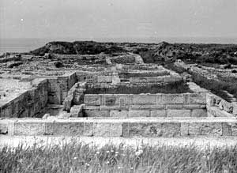

       Its walls were made of rusticated blocks resembling the stonework of the defensive structures of Chersonesos. One could enter the yard of the estate via two entrances from the main and the 3rd transverse streets. Rooms of various function - for living and working - were located around the yard. The eastern part of the house consisted of a basement with two rooms and a corridor, both cut into the rock and faced with hewn slabs. The yard had a covered gallery, the roof of which was supported by 13 limestone Doric columns. There was a pear-shaped cistern for water in the heart of the yard. Excavated fragments of red and yellow lime plaster give evidence that the walls of the rooms were plastered and painted. The presence of large cellars of areas of 100 square meters allows the hypothesis that trade was the main occupation of the owners of the house.

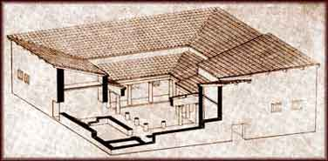  
  
*Reconstruction of the ancient house by S.G. Ryzhov*

       The tremendous size of the building, the yard of which alone covered an area of about 120 square meters, and the use of rusticated blocks have led scholars to suppose that this was a building for public functions. [R. Kh. Leper](http://www.chersonesos.org/?p=excav_schol_prs_in6&l=eng), who excavated the area in 1908-9, hypothesized that this construction was a *bouleuteion*, a house for meetings of the city council.

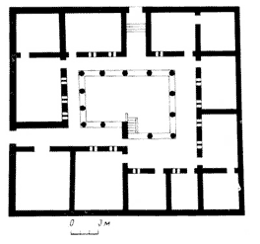

### Excavations in 1978-1980 proved that in the Hellenistic period there were two houses here sharing a wall which divided the block into equal parts measuring 625 square meters each. Where in the 4th and 3rd centuries BC there had only been two houses, from the 11th to the 14th centuries six houses and a small chapel were located. Today one can see a yard and three rooms of a medieval house in the northern corner of the block.

Eastern basilica

     As a result of coastal erosion, which resulted in the collapse of the eastern section of the church, practically nothing remains of this structure. The stone walls and marble columns have disappeared. Even those parts of the church which remain undamaged are covered with grass to the extent that it is hardly possible to determine the plan and size of the building. This church was uncovered in 1876 during excavations by the Odessa Society of History and Antiquities and was studied in 1908 by [R. Kh. Leper](http://www.chersonesos.org/?p=excav_schol_prs_in6&l=eng).

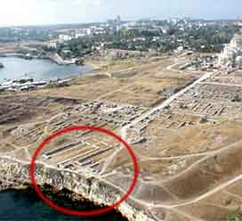

     The church was probably built in the late 6th or 7th centuries and was one of the largest in the city. It is 32 meters long and 15 meters wide. The reconstruction by Yu. G. Lositsky demonstrates that the western facade of the basilica faced the main street. This facade was decorated with the four-column portico of the exonarthex, the exterior vestibule of the church, whence parishioners entered the interior vestibule, or narthex. Two rows of columns divided the church into three longitudinal halls: the nave and two side aisles. The nave was approximately 9 meters wide; it ended in a semicircular apse, the area containing the altar. The floor of the church was covered with mosaics in a simple geometric design of transverse circles. A cruciform memorial church connected to the northern aisle of the basilica was used until the 10th century.

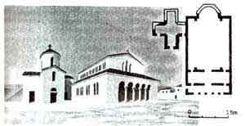

     The steep promontory which in antiquity supported a section of the defensive wall and the basilica today affords a pleasant view of the bay, the open sea, and northern Sevastopol.

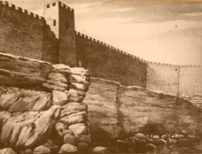

Cave church

|  |  |  |
| --- | --- | --- |
|  |  | An interesting early Christian structure, often called the cave church, is located within the third block of the [main street](http://www.chersonesos.org/?p=ct_map23&l=eng). It was carved out of the rock in the form of a gaunt quadrangle with three niches (conches) on each side. One descended into the underground space by a staircase, the upper part of which was carved out of rock; the lower part was wooden. Notches for a covering over the open entrance are visible in the rock. There had probably been a cistern for salting fish in this area before it was remodeled into a church. |

       The dating of the church is problematic: some scholars date it to the 5th century, others assert that this was a secret church for the early Christians of the first centuries AD. A chapel was later erected above the church; only a part of its apse has survived.  
  
       The cave church was discovered in 1883 during excavations by the Odessa Society of History and Antiquities. Judging from finds, one can surmise that there were several burials inside this structure. Architectural details, coins, and ceramic lamps were also excavated.  
  
       In 1980-1984 S. A. Belyaev directed further excavations and provided architectural measurements of the church. He subsequently devised a reconstruction of the church and suggested that people entered the underground space not from above, but through a room which has not been preserved.

|  |  |  |
| --- | --- | --- |
| *Church. Cross-section. Reconstruction. View of the eastern apse* |  | *Entrance to the church. Reconstruction* |

### In spite of the fact that today the church is nothing but a strange hollow in the ground, scholars have put forth plausible reconstructions. The church was once as resplendent as the other churches of Chersonesos. A hypothesis exists that relics of an unknown martyr were kept in this church, which is why it is often called the memorial church. It is interesting that the church probably existed here throughout reconstructions of the neighboring block and the Chersonites utilized it to the end of the city's existence.

Uvarov Basilica

       Proceeding along the northern seashore of Chersonesos and passing the 19th century embankment of the artillery battery, one arrives at the Uvarov Basilica. A small fragment of the medieval city wall, which defended the city from the direction of the sea, is preserved above a precipice. At one point the wall and some residential quarters fell into the sea, because this part of the bank had been eroded. The Uvarov Basilica has not escaped this sad fate: a fragment of the apse and the northern part of the building fell into the sea after excavations in the 19th century.

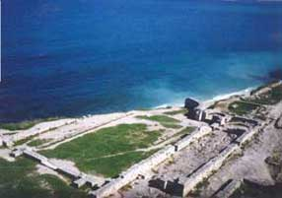  
*The Uvarov Basilica.  
Modern view*

       The complex consisting of the basilica, the [baptistery](http://www.chersonesos.org/?p=ct_map28&l=eng), and a church with a three-lobed apse which has not survived occupied the block, was probably the religious center of medieval Chersonesos. The basilica, excavated in 1853 by Count A. S. Uvarov after whom it received its name, took up the most surface area of the block.

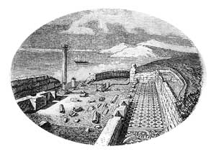  
*The basilica after it was discovered by Count A. S. Uvarov.  
19th century engraving.*

       The Uvarov Basilica was the largest church in Crimea measuring 50 meters in length and 22 meters in width, and was divided into three longitudinal rooms, or naves. One entered the basilica from the wide 5th transverse street.

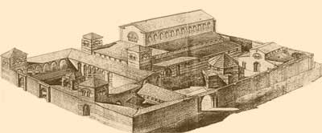  
*Front view of the basilica.   
Reconstruction.*

       The 5th transverse street led to a covered arcade with a mosaic floor at the western facade of the basilica. From there three doors opened into the exterior (*exonarthex*) and interior (*narthex*) vestibules, whence one proceeded through the central or two side entrances into the nave and aisles. Rows of marble columns separated the nave from the aisles. The nave was 36 meters long and 11 meters wide; it ended in the eastern part of the church in a semicircular apse. The floor of the nave was covered with marble slabs. The aisles were smaller in height and width (4 meters), and were much darker than the nave because of the absence of windows.

|  |  |  |
| --- | --- | --- |
| *Mosaics in the vestibule of the basilica.* |  | The floors of the aisles were decorated with mosaics: a bright geometrical ornament in black, red, yellow, and white tessarae against a white background. The mosaic of the southern aisle included a Greek inscription in black tessarae: "A prayer for Malchos and all his relatives." This mosaic was transported to St. Petersburg in 1853 and today it decorates the floor of a hall in the State Hermitage Museum. |
| A long narrow gallery was built on the southern side of the basilica. Beyond the exonarthex was a wide yard (*atrium*) with a fountain (*phial*) in the middle and covered galleries on each side. At the southern side of the complex, where now stands the high lattice tower of a lighthouse, stood a building connected with the basilica by a covered gallery. It may have been the house of a priest. |  |  |

### Constructed in the late 5th - early 6th centuries, the basilica was rebuilt more than once. Major repairs date to the tenth century.        Many scholars suppose that it was precisely this basilica that served as the city's central church devoted to Sts. Peter and Paul and mentioned in written sources.

### SHAPE \\* MERGEFORMAT

Baptistery

Part of the [Uvarov basilica](http://www.chersonesos.org/?p=ct_map27&l=eng) complex, the baptistery was discovered in 1876 during excavations by the Odessa Society of History and Antiquities. Further investigations occurred in 1901. The Christian rite of baptism took place in buildings called baptisteries after the Greek word *baptisterion*, meaning "font."  
The Chersonesan baptistery was cruciform in plan, three arms ending in niches (exedrae). The central entrance was located in the western arm. The structure was covered by a spherical vault; semi-vaulted niches took the form of curved apses. The northern and southern apses were three-edged, the larger eastern apse was pentahedral. Layers of bricks alternated with stone masonry in the lowest meter of the wall.

|  |  |  |
| --- | --- | --- |
| *The baptistery. A reconstruction by S. A. Belyaev* |  | *The baptistery. A cross-section* |

The extraordinary state of preservation of the walls after excavation revealed traces of three windows in the sanctuary apse. These windows contained brick arches similar to those of the doorways. A stone threshold was preserved in the western part of the baptistery. In 1901 K. K. Kosciuszko-Valuzhinich wrote: "*The heavily worn surface of the threshold gives evidence for much movement through this door*."

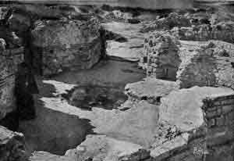  
*A view of the baptistery in the early 20th century*

The round font was cut in the very middle of the stone floor of the baptistery and was entered from the eastern side by a step. A cruciform hollow was cut in the base. The interior surface of the font and lower part of the walls were faced with marble; the upper part was covered with frescos. The vaulting over the font and in the exedrae was decorated with mosaics, which, according to predominant dark blue and gold mosaic tessarae, depicted a blue sky with gold stars, heaven. A reservoir located nearby supplied the baptistery with water through a pipe laid under the floor; the outgoing water traveled through the channel under the floor of the baptistery to a pit outside the building.

|  |  |  |
| --- | --- | --- |
|  |  | The majority of modern scholars associate the Uvarov baptistery with the location of Prince Volodymyr's baptism. Unfortunately for the historical and archaeological integrity of the site, an event occurred in 1997 to commemorate this legendary baptism despite protests raised by the administration of the preserve: with the help of a helicopter the Orthodox Church fixed a metal arbor above the font. |

This rusting structure has distorted the appearance of the archaeological site, which was shortly before investigated and restored. Restoration work was aimed at providing a more complete view of the building in relation to the rite of baptism as practiced in Cherson.

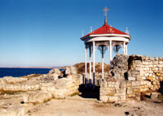  
*The baptistery with the so-called rotunda.   
The site at present*

Bell

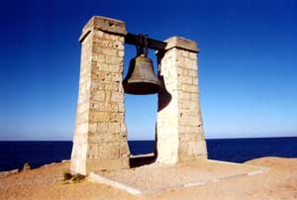

       The bell is a favorite subject of photographers. Pictures of it decorate numerous books and pamphlets about Chersonesos, although it is completely unrelated to the ancient city.   
  
       In spite of this, its location on the picturesque promontory above the sea and its mossy surface, which in some people's perception is probably associated with the romance of antiquity, make the bell a famous sight at Chersonesos; so it is very uncommon when a visitor does not ask a tour guide for the story of the bell.  
       The inscription on the bell is difficult to decipher: "This bell was cast… St. Nicholas the Miracle in Taganrog of the Turkish artillery weighing [351?] poods [1 pood = 16.38 kg] in the year of 1776, month of August, day ..."   
       In 1783 Emperor Alexander I ordered the bell to be transported to Sevastopol to be fitted in the Church of St. Nicholas which was being constructed there. After the Oriental war of 1853-1856, the allied armies of Great Britain and France took 13 church bells out of Sevastopol together with other war booty. Many years later, a bell with a Russian inscription was found in Notre-Dame de Paris, and nobody knew how it had appeared there. Thanks to certain diplomatic efforts undertaken by both sides, and especially by the French consul in Sevastopol, L.I. Ge, the bell was returned to the belfry of the monastery at Chersonesos from where it was presumably taken. The "captive" was solemnly returned on November 23, 1913, an event marked with a large attendance and a religious procession. In a letter to L. I. Ge President Poincare of France wrote that he returned the bell to Russia "as a sign of alliance and friendship." In their turn, the Russian government awarded the French consul the order of St. Vladimir of the 4th degree.  
       The monastery was closed in 1925 by the new authorities, and two years later all its bells were sent away to be recast. Only one bell escaped this sad fate because the Department of the Security of Navigation of the Black and Azov Seas proposed to place it on the coast as a signal bell. Its distinct and deep peal was meant to sound the signal to passing ships in foggy weather.

|  |  |  |
| --- | --- | --- |
| "BELL-MANIA" |  |  |
|  |  |  |

       Although all these facts are verifiable, it is absolutely impossible to state that the bell now standing guard over the shore in Chersonesos is the same one which was returned by France. Its tongue has been removed but many visitors hear its voice in reply to well-aimed stones. Other visitors prefer to take pictures of the bell set against the background of inspiring sunsets which so often appear in Chersonesos...

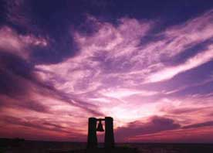

Western line of defense

     A large area to the west of the [Basilica on the hill](http://www.chersonesos.org/?p=ct_map47&l=eng) was included into the territory of the city at the end of the 5th century AD. It was secured by a newly constructed defensive line and was consequently heavily built up. In addition to residential and commercial buildings, this section included the so-called [Western basilica](http://www.chersonesos.org/?p=ct_map48&l=eng), which for a long time architecturally dominated the area.

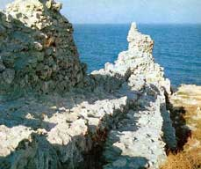

     The new western defensive line cut across the largest [necropolis](http://www.chersonesos.org/?p=city_nkrp&l=eng) of the first centuries AD. The necropolis covered the entire eastern slope down to Sandy Bay. The fortified wall protected the entrance into the city from the road approaching Chersonesos from neighboring agricultural areas.

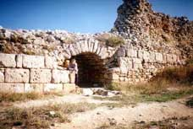

Reliquary church

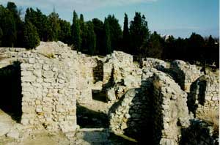

       This cruciform building is unofficially named the "Reliquary Church" because of the discovery of a small silver reliquary containing the remains of an unknown saint found under the altar during excavations in 1897. This reliquary has been located in the Hermitage Museum in St. Petersburg since 1900.

|  |  |  |
| --- | --- | --- |
| It is decorated with embossed medallions depicting Christ, Sts. Peter and Paul on one side; the Virgin Mary and two archangels on the other side; and the young saints, Sergios and Bacchus, or possibly, George and Dimitri, on the short ends. There are four crosses on the lid and four stamps dating to the reign of the emperor Justinian I (527-565) on the exterior bottom and the inner side of the lid. Art historians date this reliquary to the mid-6th century AD. |  |  |

       The plan of the building is a cross with arms of equal length. The eastern arm where the altar was located ends in an apse. Churches of this type were topped by a dome supported by the bases of the arms of the cross.

|  |  |  |
| --- | --- | --- |
|  |  | There were two back rooms flanking the eastern part of the church: the deacon's room to the right, and to the left an area containing an altar with a basin cut from a large stone block. The front wall of the basin is decorated with a relief showing a cross flanked by two cypresses. |

       In the central apse there were three semicircular benches for priests, a so-called *synthronos*. Two limestone blocks from the bishop's see stood in the middle of the synthronos.

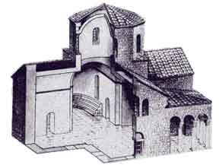  
*Reliquary church. Reconstruction.*

       [K. K. Kosciuszko-Valuzhinich](http://www.chersonesos.org/?p=excav_schol_prs_in2&l=eng) describes the discovery of the nook under the altar in 1897: "*... in the middle of the foundation we found a small tomb made of tiles accurately laid together, placed in three rows, mortared with lime, and covered with a marble slab above which was concrete used as a base for the marble floor of the altar. Thanks to such a strong cover for the small tomb, it survived all the disasters undergone by the church… On the marble plate where the reliquary stood were silver fragments: a small hook with a clasp and two fragments of the lid, and decomposed textile in which the reliquary had been wrapped. Having been invited to the excavation area, the superior of the monastery Archimandrite Alexander, in the presence of the clergy, the head of the excavation Kosciuszko-Valuzhinich, and workers opened the reliquary and found in it fragments of relics wrapped in decomposed silk, which were then carried to the new church of St. Vladimir with all appropriate solemnity. The fragments of the relics probably included finger bones, which according to the archimandrite's explanation, became black as a result of burning, so that they probably belonged to an unidentified Christian martyr who died in a fire*".

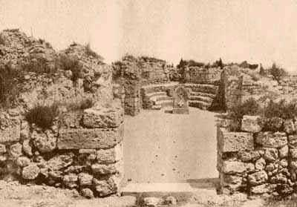  
*Reliquary church. Cross-section after excavations in 1897*

       Several meters to the west of the church were dwelling houses of the 13th and 14th centuries, which were demolished along with the Reliquary Church in a conflagration resulting from a Mongol-Tartar invasion.

|  |  |  |  |  |  |  |
| --- | --- | --- | --- | --- | --- | --- |
| Basilica in the basilica           The combination of white columns and polychrome mosaics amidst dark green bushes makes the Basilica within a Basilica one of the most striking monuments in Chersonesos. Its designated name reflects an interesting architectural pattern: here one can view two buildings, in inside the other, which functioned in various periods.  The complex was discovered in 1889 during excavations by [K. K. Kosciuszko-Valuzhinich](http://www.chersonesos.org/?p=excav_schol_prs_in2&l=eng). It consists of two three-naved basilicas belonging to different times: the earlier, larger church was constructed in the 6th century; the second, built in the late 10th century, was so compact that it fit entirely within the central nave of the first church. The marble details of the earlier church were used in the construction of the later basilica.  *The Plan of the Two Basilicas*         The floor of the 6th century basilica was covered with mosaics featuring simple geometric ornament and more complex Christian symbols. The mosaic designs of the vestibule, or *narthex*, and eastern extensions of the aisles consist of interlocking red circles against a white background.           The mosaics in the nave portray a more complicated picture. Apart from the geometric lines are Christian symbols depicting birds, circles, etc. Fragments of two lines of an ancient Greek inscription (presumably "Let God bless each brief") are preserved near the door. Nearby are pictures of a chalice, the symbol of the Eucharist, and a circle within a rhomb, the symbol of eternity.   |  |  |  | | --- | --- | --- | |  |  | In the north room/baptistery lay a mosaic of a peacock, the symbol of resurrection; its outstretched tail symbolized the starry sky; pigeons symbolized the Holy Spirit; and an anchor was a symbol of one of the three most important Christian virtues, hope. |          The mosaics were made of small pebbles of marble, colored limestone, ceramic, and smalt. The majority of the mosaics were damaged during the construction of the later basilica. The floor of the sanctuary was paved with marble. The altar was made from the top portion of a column including its capital from the earlier church and placed on the new marble floor. A small burial chapel was constructed to the south of the sanctuary of the later basilica, and an open gallery was built to the north of the earlier basilica. At present, only the side walls and column bases remain from this gallery. At the end of the 13th century the small basilica collapsed during a fire.   |  |  |  | | --- | --- | --- | | *1971: Restoration of the Complex* |  |  |   In 1971-1974 S. G. Ryzhov led further investigations and restoration at the site. Mosaics were reinforced by new mortars. |
| Basilica in the basilica  **Unfortunately, this once magnificent structure is today in a state of very poor conservation. No restoration work after the excavations of 1984 was ever organized. The structure is located on the hill in the western area of Chersonesos not far from the** [**western basilica**](http://www.chersonesos.org/?p=ct_map48&l=eng)**. The site's relatively distant location from the usual route of guided tours has resulted in the almost complete disrepair of the remains of the church.**  **The building complex of the Basilica on the Hill.  Aerial view**  **The site was discovered in 1890 during excavations by** [**K. K. Kosciuszko-Valuzhinich**](http://www.chersonesos.org/?p=excav_schol_prs_in2&l=eng)**. In 1973-1984 S. A. Belyaev led additional excavations in the basilica and established that the 10th century church discovered by Kosciuszko-Valuzhinich was built on the ruins of an earlier, larger basilica, second only to the** [**Uvarov Basilica**](http://www.chersonesos.org/?p=ct_map27&l=eng)**. In turn, this earlier basilica had been constructed on the site of a manufacturing complex: a potter's kiln.  The later basilica comprised a three-naved plan divided by two rows of four columns each. There were two vestibules - the narthex and exonarthex. The floors were decorated with mosaics. Near the basilica were some buildings used both for dwelling and business.**  **The Basilica on the Hill. A reconstruction by S. A. Belyaev**  **There were approximately 150 burials in and around the church. S. A. Belyaev conjectured that some of these burials contained the remains of Rus' warriors and Vikings belonging to Prince Volodymyr's retinue who perished during the** [**siege of Cherson**](http://www.chersonesos.org/?p=history_tls3&l=eng)**. All the buildings together with the basilica and the graves were surrounded by a stone fence.  S. A. Belyaev suggested that the Basilica on the Hill was in fact the "church on the mountain in Korsun'" which, according to chronicles, was built by Prince Volodymyr in commemoration of his baptism.** |

### 

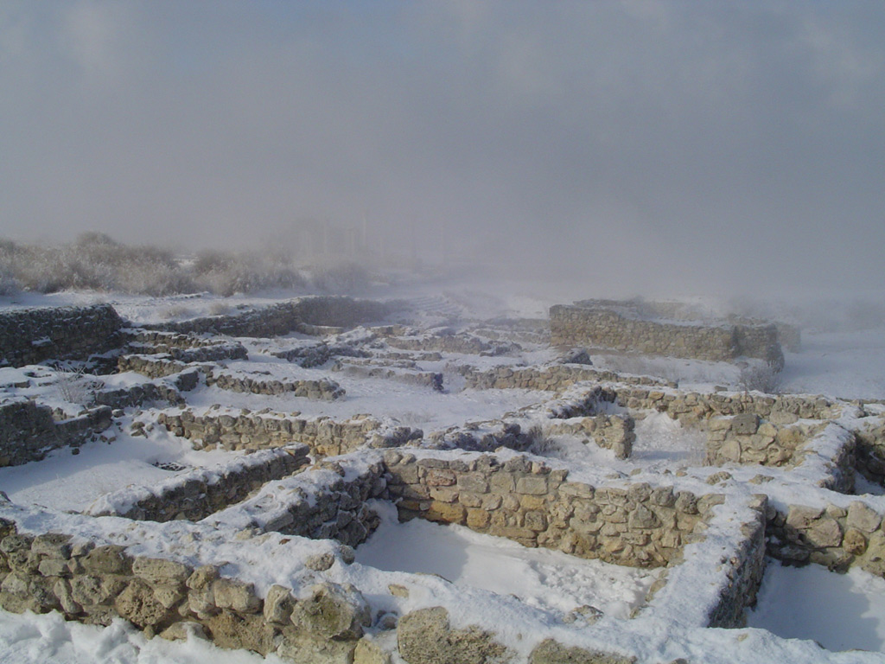

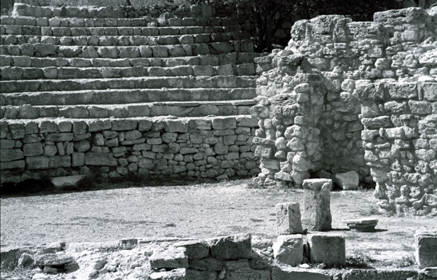   
Author:Kondurina Alena

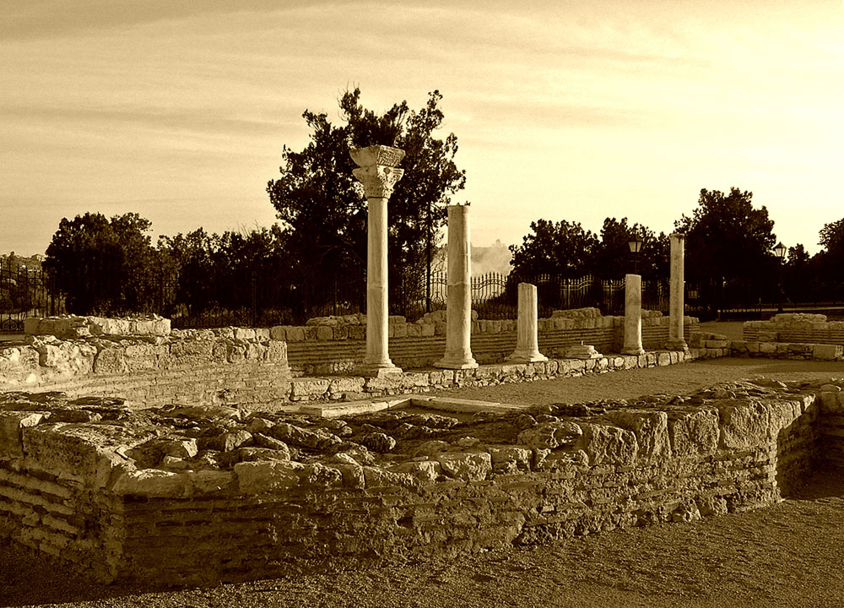

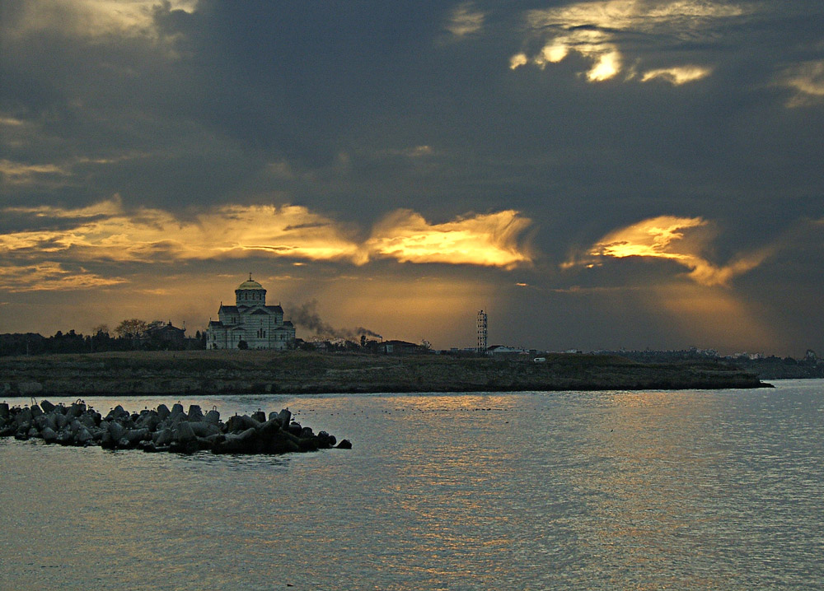 by Harina Natalva http://www.chersonesos.org/images/gallery/big26.jpg

The remains of the city of Chersonesos

**Chersonesos** ([Greek](http://en.wikipedia.org/wiki/Greek_language): Χερσόνησος, [Latin](http://en.wikipedia.org/wiki/Latin_language): *Chersonesus*, [Old East Slavic](http://en.wikipedia.org/wiki/Old_East_Slavic): Корсунь, *Korsun*, [Russian](http://en.wikipedia.org/wiki/Russian_language)/[Ukrainian](http://en.wikipedia.org/wiki/Ukrainian_language): Херсонес, *Khersones*; see also [List of traditional Greek place names](http://en.wikipedia.org/wiki/List_of_traditional_Greek_place_names)), also transliterated as *Chersonese*, *Chersonesos*, *Cherson*, was an [ancient Greek](http://en.wikipedia.org/wiki/Ancient_Greece) colony founded approximately 2500 years ago in the southwestern part of [Crimea](http://en.wikipedia.org/wiki/Crimea), known then as [Taurica](http://en.wikipedia.org/wiki/Taurica). The colony was established in the [6th century BC](http://en.wikipedia.org/wiki/6th_century_BC) by settlers from [Heraclea Pontica](http://en.wikipedia.org/wiki/Heraclea_Pontica).

The ancient city is located on the shore of the [Black Sea](http://en.wikipedia.org/wiki/Black_Sea) at the outskirts of [Sevastopol](http://en.wikipedia.org/wiki/Sevastopol) in [Crimea](http://en.wikipedia.org/wiki/Crimea), [Ukraine](http://en.wikipedia.org/wiki/Ukraine), where it is referred to as *Khersones*. It has been nicknamed the "Ukrainian [Pompeii](http://en.wikipedia.org/wiki/Pompeii)" and "Russian [Troy](http://en.wikipedia.org/wiki/Troy)". The name "Chersonesos" in Greek means simply "peninsula", and aptly describes the site on which the colony was established. It should not be confused with the Tauric Chersonese, the name often applied to the whole of the southern Crimea along with "[Taurica](http://en.wikipedia.org/wiki/Taurica)".

During much of the classical period the town was a [democracy](http://en.wikipedia.org/wiki/Democracy) ruled by a group of elected [archons](http://en.wikipedia.org/wiki/Archon) and a council called the Damiorgi. As time went on the government grew more oligarchic, with power concentrated in the hands of the archons. A form of oath sworn by all the citizens in the [3rd century BC](http://en.wikipedia.org/wiki/3rd_century_BC) has survived to the present day.

|  |
| --- |
| Contents [[hide](javascript:toggleToc())]   * [1](http://en.wikipedia.org/w/index.php?title=Chersonesos&printable=yes" \l "History%23History) History * [2](http://en.wikipedia.org/w/index.php?title=Chersonesos&printable=yes" \l "Archaeological_site%23Archaeological_site) Archaeological site * [3](http://en.wikipedia.org/w/index.php?title=Chersonesos&printable=yes" \l "Current_studies%23Current_studies) Current studies * [4](http://en.wikipedia.org/w/index.php?title=Chersonesos&printable=yes" \l "References_and_further_reading%23References_and_further_reading) References and further reading * [5](http://en.wikipedia.org/w/index.php?title=Chersonesos&printable=yes" \l "External_links%23External_links) External links |

## [[edit](http://en.wikipedia.org/w/index.php?title=Chersonesos&action=edit&section=1)] History



Chersonesos and other Greek colonies along the north coast of the Black Sea in the 5th century [BCE](http://en.wikipedia.org/wiki/Common_Era).

In the late [2nd century BC](http://en.wikipedia.org/wiki/2nd_century_BC) Chersonesos became a dependency of the [Bosporan Kingdom](http://en.wikipedia.org/wiki/Bosporan_Kingdom). It was subject to [Rome](http://en.wikipedia.org/wiki/Roman_Empire) from the middle of the [1st century BC](http://en.wikipedia.org/wiki/1st_century_BC) until the [370s](http://en.wikipedia.org/wiki/370s) AD, when it was captured by the [Huns](http://en.wikipedia.org/wiki/Huns).

The site of Chersonesos is an exposition of excavated buildings and structures dating to different periods of the city's life: Hellenistic, Roman, and especially Byzantine. It covers a large area (45 ha) and provides an exhaustive representation of the city's regular plan (the so-called Hippodamean system), which changed only slightly in the two-thousand-year history of Chersonesos. Although the site of Chersonesos is located along a picturesque seashore within the city limits of Sevastopol, it is set apart from the modern city. For these reasons it is one of the most popular tourist attractions in Ukraine today. Every year leading Ukrainian and foreign scholarly institutions conduct scientific research at the site.  
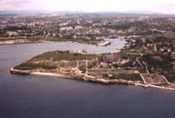       In the earliest period of its existence, Chersonesos occupied an insignificant part of the Heraklean Peninsula, initially only the territory of the western shore of Quarantine Bay. Later, the city borders were widened more than once, the total area growing almost twofold, and by the beginning of the 1st century AD they reached the eastern shore of Sandy Bay.  
       The ancient city is, first and foremost, a fortress with a formidable line of defense aligned with the topography of the territory and intended to withstand long sieges and assaults by hostile armies. The early, relatively small settlement on Quarantine Bay was surrounded by a short wall which was fortified in the late 4th - early 3rd centuries BC. Subsequently, the total length of the defensive walls of Chersonesos reached approximately 3.5 kilometers in length, 3.5 - 4 meters in width, 8 - 10 meters in height, with towers stretching 10 - 12 meters high. Eventually the entire area of the city, covering about 30 hectares, was protected on all sides by defensive walls.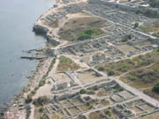  
       As in every city, the limits of which were determined by defensive walls, Chersonesos had narrow streets and small squares which were located as a rule in the busiest districts. The regular plan of perpendicular streets carved blocks into approximately equal areas. In the ancient period each block consisted of 2 - 4 residential houses. In the medieval period some blocks were combined and buildings were made more compact because the number and width of streets were decreased. Although several blocks and entire districts changed appearance, the regular system of urban planning inherited from the ancient period was preserved.  
       Necropoleis (cemeteries) were located outside the city walls and along roads. In the ancient period the deceased were buried in graves or vaults; this ritual was preserved even after the conversion of the population to Christianity. A monument (stela) was usually placed at the grave, which initially indicated the deceased's name, and later his/her age as well. Burials within the city took place only from the 10th - 14th centuries, and as a rule only inside or near churches and chapels.  
       Craftsmen's workshops and residential quarters were located outside the city near the defensive walls, and agricultural plots of land were situated very close to these populated districts.  
       Wars, fires, changes in population and religion all left their mark on the appearance of the city, which is why the architectural portrait of Chersonesos changed more than once during its two thousand-year history. Dilapidated or burnt buildings were taken down and new structures were erected in their place. During construction the remains of earlier buildings were usually covered with debris or were incorporated into the new foundations. All the buildings relating to pagan cults were demolished in this way in the early Middle Ages after the advent of Christianity.  
       Constant raids by nomadic tribes in the 12th - 14th centuries undermined the economy of Chersonesos. As a result of a Mongol-Tatar raid in the late 14th century the city was destroyed. For a long time after this event Chersonesos was a site of ashes: burnt-down houses, churches and fortifications. In the course of time Chersonesos became overgrown with grass and shrubbery and was used as a source of building materials. This was the state of Chersonesos when initial excavations were begun in the late 1820s.

It became a [Byzantine](http://en.wikipedia.org/wiki/Byzantine_Empire) possession during the early [Middle Ages](http://en.wikipedia.org/wiki/Middle_Ages), but Byzantine rule was slight; according to [Theophanes](http://en.wikipedia.org/wiki/Theophanes) and others, Chersonesos was the residence of a [Khazar](http://en.wikipedia.org/wiki/Khazar) tudun in the late [600s](http://en.wikipedia.org/wiki/600s). There was a small imperial garrison more for its protection than for its control. It was useful to Byzantium in two ways: as an observation point to watch the barbarian tribes, and its isolation made it a popular place of exile for those who angered the Roman and later Byzantine governments. Among its more famous "inmates" were Popes [Clement I](http://en.wikipedia.org/wiki/Clement_I) and [Martin I](http://en.wikipedia.org/wiki/Martin_I), and the deposed [Byzantine Emperor](http://en.wikipedia.org/wiki/Byzantine_Emperor) [Justinian II](http://en.wikipedia.org/wiki/Justinian_II).

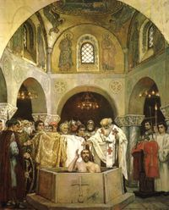



[Viktor Vasnetsov](http://en.wikipedia.org/wiki/Viktor_Vasnetsov): *Baptism of Saint Prince Vladimir in Korsun'.*

In 838 [Emperor Theophilus](http://en.wikipedia.org/wiki/Theophilus_(emperor)) sent the nobleman [Petronas Kamateros](http://en.wikipedia.org/w/index.php?title=Petronas_Kamateros&action=edit), who had recently overseen the construction of the Khazar fortress of [Sarkel](http://en.wikipedia.org/wiki/Sarkel), to take direct control over the city and its environs. It remained in Byzantine hands until the [980s](http://en.wikipedia.org/wiki/980s), when it reportedly fell to [Kiev](http://en.wikipedia.org/wiki/Kiev). [Vladimir the Great](http://en.wikipedia.org/wiki/Vladimir_the_Great) agreed to evacuate the fortress only if [Basil II](http://en.wikipedia.org/wiki/Basil_II)'s sister [Anna Porphyrogeneta](http://en.wikipedia.org/wiki/Family_life_and_children_of_Vladimir_I" \l "Anna_Porphyrogeneta) would be given him in marriage. The demand caused a scandal in Constantinople, as imperial princesses had never been married to non-Greeks before. As a pre-condition for the marriage settlement, Vladimir was baptized here in [988](http://en.wikipedia.org/wiki/988), thus paving the way to the [Baptism of Kievan Rus'](http://en.wikipedia.org/wiki/Baptism_of_Kievan_Rus'). Thereafter Korsun' was evacuated.

Since this campaign is not recorded in Greek sources, historians have suggested that this account actually refers to the events of the [Rus'-Byzantine War (1043)](http://en.wikipedia.org/wiki/Rus'-Byzantine_War_(1043)) and to a [different Vladimir](http://en.wikipedia.org/wiki/Vladimir_of_Novgorod). In fact, most valuables looted by the Slavs in Korsun' made their way to [Novgorod](http://en.wikipedia.org/wiki/Novgorod), where they were preserved in the [Saint Sophia Cathedral](http://en.wikipedia.org/wiki/Saint_Sophia_Cathedral_in_Novgorod) until the 20th century. One of the most interesting items from this "Korsun Treasure" is the copper [Korsun Gate](http://en.wikipedia.org/wiki/Rus'-Byzantine_War_(1043)), supposedly captured by the Novgorodians in Korsun' and now part of the St. Sophia Cathedral.

After the [Fourth Crusade](http://en.wikipedia.org/wiki/Fourth_Crusade) Chersonesos became dependent on the [Empire of Trebizond](http://en.wikipedia.org/wiki/Empire_of_Trebizond), and then fell under [Genoese](http://en.wikipedia.org/wiki/Genoa) control in the early [1300s](http://en.wikipedia.org/wiki/1300s). In [1299](http://en.wikipedia.org/wiki/1299) the town was sacked by the armies of [Nogai Khan](http://en.wikipedia.org/wiki/Nogai_Khan). A century later it was destroyed by [Edigu](http://en.wikipedia.org/wiki/Edigu) and was permanently abandoned. In the late [19th century](http://en.wikipedia.org/wiki/19th_century), St Vladimir's Cathedral (completed [1892](http://en.wikipedia.org/wiki/1892)) was built on a small hill overlooking the site; designed in Byzantine style, it was intended to commemorate the site of Vladimir's baptism.

## [[edit](http://en.wikipedia.org/w/index.php?title=Chersonesos&action=edit&section=2)] Archaeological site

[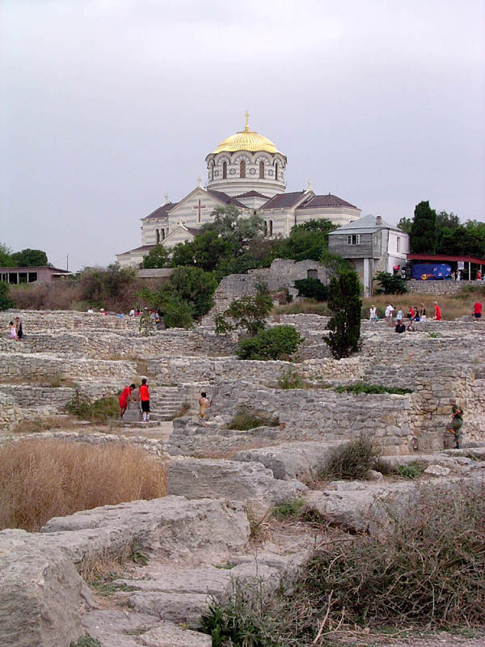](http://en.wikipedia.org/wiki/Image:Kersones_st_vladimir.jpg)



St Vladimir's Cathedral overlooks the extensive excavations of Chersonesos

Chersonesos' ancient ruins are presently located in one of Sevastopol's suburbs. They were excavated by the Russian government, starting from [1827](http://en.wikipedia.org/wiki/1827). They are today a popular tourist attraction, protected by the state as an archaeological park.

The buildings mix influences of Greek, [Roman](http://en.wikipedia.org/wiki/Ancient_Rome) and [Byzantine](http://en.wikipedia.org/wiki/Byzantium) culture. The defensive wall is hundreds of meters long. Buildings include Roman [amphitheatre](http://en.wikipedia.org/wiki/Amphitheatre) and a Greek temple.

The largest portion of the site is "Chora", several square kilometres of ancient but now barren farmland, with remains of [wine](http://en.wikipedia.org/wiki/Wine) presses and defensive [towers](http://en.wikipedia.org/wiki/Tower). According to archaeologists, the evidence suggests that the locals were paid to do the farm work instead of being [enslaved](http://en.wikipedia.org/wiki/Slavery).

The excavated tombstones hint at burial practices that were different from the Greek ones. Each stone marks the tomb of an individual, instead of the whole family and the decorations include only objects like sashes and weapons, instead of burial statues. Over half of the tombs archaeologists have found have bones of children. Burned remnants suggest that the city was plundered and destroyed.

## [[edit](http://en.wikipedia.org/w/index.php?title=Chersonesos&action=edit&section=3)] Current studies

The Institute of Classical Archaeology of the [University of Texas at Austin](http://en.wikipedia.org/wiki/University_of_Texas_at_Austin) and the local Archaeological Park has investigated the site since [1992](http://en.wikipedia.org/wiki/1992). The Ukrainian government has included the site on its tentative [World Heritage List](http://en.wikipedia.org/wiki/World_Heritage_List). The site, however, is in danger of further urban encroachment and coastal [erosion](http://en.wikipedia.org/wiki/Erosion).

## [[edit](http://en.wikipedia.org/w/index.php?title=Chersonesos&action=edit&section=4)] References and further reading

* Anokhin, V.A. *The Coinage of Chersonesus: IV century B.C.–XII century A.D.*. Oxford : British Archaeological Reports, 1980 (paperback, [ISBN 086054074X](http://en.wikipedia.org/w/index.php?title=Special:Booksources&isbn=086054074X)).
* Carter, Joseph Coleman; Crawford, Melba; Lehman, Paul; Nikolaenko, Galina; Trelogan, Jessica. "The Chora of Chersonesos in Crimea, Ukraine", *American Journal of Archaeology*, Vol. 104, No. 4. (2000), pp. 707–741.
* Carter, Joseph Coleman; Mack, Glenn Randall. *Crimean Chersonesos: City, Chora, Museum, and Environs*. Austin, TX: David Brown Book Company, 2003 (paperback, [ISBN 0970887922](http://en.wikipedia.org/w/index.php?title=Special:Booksources&isbn=0970887922)).
* Kozelsky, Mara. "Ruins into Relics: The Monument to Saint Vladimir on the Excavations of Chersonesos, 1827–57", *The Russian Review*, Vol. 63, No. 4. (2004), pp. 655–672.
* Norwich, John Julius. *Byzantium: The Early Centuries*. New York: Alfred A. Knopf, 1989 (hardcover, [ISBN 0-394-53778-5](http://en.wikipedia.org/w/index.php?title=Special:Booksources&isbn=0394537785)).
* Saprykin, S.Yu. *Heracleia Pontica and Tauric Chersonesus before Roman domination: (VI–I centuries B.C.)*. Amsterdam: A.M. Hakkert, 1997 ([ISBN 9025611095](http://en.wikipedia.org/w/index.php?title=Special:Booksources&isbn=9025611095)).

## [[edit](http://en.wikipedia.org/w/index.php?title=Chersonesos&action=edit&section=5)] External links

* [Bulletin of the Odessa Numismatics Museum](http://www.museum.com.ua/en/nauch_isled/vestn.htm)
* [Chersonesos](http://www.accentonunderstanding.org/Ukraine/Ukraine topics/black_sea.htm): Online resources
* [National Preserve of Tauric Chersonesos, Sevastopol](http://www.chersonesos.org/)
* [Cherson on Regnal Chronologies](http://www.hostkingdom.net/crimea.html" \l "Cherson)
* [Brief History of Antique Cities of Tauria and Their Coinage.](http://www.museum.com.ua/en/istor/tavria/tavria.htm)

[Coordinates](http://en.wikipedia.org/wiki/Geographic_coordinate_system): [44°34′N, 33°26′E](http://tools.wikimedia.de/~magnus/geo/geohack.php?params=44_34_N_33_26_E_type:city)

|  |  |
| --- | --- |
| [**North Pontic Greek colonies**](http://en.wikipedia.org/wiki/Colonies_in_antiquity) |  |
| [Tyras](http://en.wikipedia.org/wiki/Tyras) • [Olbia](http://en.wikipedia.org/wiki/Olbia%2C_Ukraine) • [Borysthenes](http://en.wikipedia.org/wiki/Berezan_Island) • [Eupatoria](http://en.wikipedia.org/wiki/Eupatoria) • Chersonesos • [Charax](http://en.wikipedia.org/wiki/Charax%2C_Crimea) • [Theodosia](http://en.wikipedia.org/wiki/Theodosia) [Kimmerikon](http://en.wikipedia.org/wiki/Kimmerikon) • [Nymphaion](http://en.wikipedia.org/wiki/Nymphaion) • [Tyritake](http://en.wikipedia.org/wiki/Tyritake) • [Panticapaeum](http://en.wikipedia.org/wiki/Panticapaeum) • [Myrmekion](http://en.wikipedia.org/wiki/Myrmekion) [Kepoi](http://en.wikipedia.org/wiki/Kepoi) • [Phanagoria](http://en.wikipedia.org/wiki/Phanagoria) • [Hermonassa](http://en.wikipedia.org/wiki/Tmutarakan) • [Gorgippia](http://en.wikipedia.org/wiki/Anapa) • [Pitiunt](http://en.wikipedia.org/wiki/Pitsunda) • [Dioscurias](http://en.wikipedia.org/wiki/Sukhumi) • [Tanais](http://en.wikipedia.org/wiki/Tanais) |

Retrieved from "<http://en.wikipedia.org/wiki/Chersonesos>"

[Categories](http://en.wikipedia.org/wiki/Special:Categories): [Ancient Greek cities](http://en.wikipedia.org/wiki/Category:Ancient_Greek_cities) | [Pontic Greeks](http://en.wikipedia.org/wiki/Category:Pontic_Greeks) | [6th century BC establishments](http://en.wikipedia.org/wiki/Category:6th_century_BC_establishments) | [Ruins](http://en.wikipedia.org/wiki/Category:Ruins) | [Sevastopol](http://en.wikipedia.org/wiki/Category:Sevastopol) | [Archaeological sites in Ukraine](http://en.wikipedia.org/wiki/Category:Archaeological_sites_in_Ukraine) | [Khazar towns](http://en.wikipedia.org/wiki/Category:Khazar_towns) | [Bosporan Kingdom](http://en.wikipedia.org/wiki/Category:Bosporan_Kingdom) | [Megarian colonies](http://en.wikipedia.org/wiki/Category:Megarian_colonies) | [Greek colonies in Crimea](http://en.wikipedia.org/wiki/Category:Greek_colonies_in_Crimea)

##### Views

* [Article](http://en.wikipedia.org/wiki/Chersonesos)
* [Discussion](http://en.wikipedia.org/wiki/Talk:Chersonesos)
* [Edit this page](http://en.wikipedia.org/w/index.php?title=Chersonesos&action=edit)
* [History](http://en.wikipedia.org/w/index.php?title=Chersonesos&action=history)

##### Personal tools

* [**Sign in / create account**](http://en.wikipedia.org/w/index.php?title=Special:Userlogin&returnto=Chersonesos)

##### Navigation

* [Main page](http://en.wikipedia.org/wiki/Main_Page)
* [Contents](http://en.wikipedia.org/wiki/Wikipedia:Contents)
* [Featured content](http://en.wikipedia.org/wiki/Wikipedia:Featured_content)
* [Current events](http://en.wikipedia.org/wiki/Portal:Current_events)
* [Random article](http://en.wikipedia.org/wiki/Special:Random)

##### interaction

* [About Wikipedia](http://en.wikipedia.org/wiki/Wikipedia:About)
* [Community portal](http://en.wikipedia.org/wiki/Wikipedia:Community_Portal)
* [Recent changes](http://en.wikipedia.org/wiki/Special:Recentchanges)
* [Contact us](http://en.wikipedia.org/wiki/Wikipedia:Contact_us)
* [Make a donation](http://wikimediafoundation.org/wiki/Fundraising)
* [Help](http://en.wikipedia.org/wiki/Help:Contents)

##### Search

Top of Form

Bottom of Form

##### Toolbox

* [What links here](http://en.wikipedia.org/wiki/Special:Whatlinkshere/Chersonesos)
* [Related changes](http://en.wikipedia.org/wiki/Special:Recentchangeslinked/Chersonesos)
* [Upload file](http://en.wikipedia.org/wiki/Special:Upload)
* [Special pages](http://en.wikipedia.org/wiki/Special:Specialpages)
* [Printable version](http://en.wikipedia.org/w/index.php?title=Chersonesos&printable=yes&printable=yes)
* [Permanent link](http://en.wikipedia.org/w/index.php?title=Chersonesos&oldid=119338396)
* [Cite this article](http://en.wikipedia.org/w/index.php?title=Special:Cite&page=Chersonesos&id=119338396)

##### In other languages

* [Català](http://ca.wikipedia.org/wiki/Quersonesos)
* [Deutsch](http://de.wikipedia.org/wiki/Chersones_(Stadt))
* [Español](http://es.wikipedia.org/wiki/Quersoneso_(ciudad))
* [Français](http://fr.wikipedia.org/wiki/Chersonèsos)
* [Italiano](http://it.wikipedia.org/wiki/Cherson)
* [Nederlands](http://nl.wikipedia.org/wiki/Chersonesos)
* [‪Norsk (bokmål)‬](http://no.wikipedia.org/wiki/Chersonesus_(Pontus_Euxinus))
* [Polski](http://pl.wikipedia.org/wiki/Chersonez_Taurydzki)
* [Português](http://pt.wikipedia.org/wiki/Quérson)
* [Русский](http://ru.wikipedia.org/wiki/Херсонес_Таврический)
* [Українська](http://uk.wikipedia.org/wiki/Херсонес_Таврійський)





* This page was last modified 20:43, 31 March 2007.

All text is available under the terms of the [GNU Free Documentation License](http://en.wikipedia.org/wiki/Wikipedia:Text_of_the_GNU_Free_Documentation_License).

**"Ancient Chersonesos" of Strabo**

"*If one sails along the [Crimean] coast, there is a big cape which projects into the sea… and on this cape is situated a city of the Herakleians… called Chersonesos… Then comes the Ancient Chersonesos, which laid in ruins, and then a harbor with narrow mouth where the Tavrians used to prepare their predatory bands to attack those who fled there for refuge. It is called Symbolon Limen ("Signal Harbor")..."* (Strabo, VII, 4, 2).

That is all we know of the "Ancient Chersonesos," which is sometimes called "Old Chersonesos" or "Strabo's Chersonesos".[Strabo](http://www.chersonesos.org/?p=history_sour4&l=eng), who was an ancient Greek geographer and historian and worked on his Geography in the late of the 1st c. BC - early 1st c. AD, supplies only two clear evidences. First, the Ancient Chersonesos was a town located somewhere nearby the city of Chersonesos. Second, the Ancient Chersonesos had declined and had been depopulated by the moment when Strabo was writing his "Geography"

The problems of the location and the foundation date of this town have been being discussed for ages. F. K. Brun suggested that the Ancient Chersonesos was located in the south coast of the Crimea near the cape of Aya. [K. E. Grinevich](http://www.chersonesos.org/?p=excav_schol_prs_in3&l=eng) searched for this town on the sea bottom at the lighthouse of Chersonesos. He made underwater investigations at this place in 1930 and 1931, but without any result.

Nowadays, there are two hypotheses that are considered nore or less grounded and are based against the background of [K. K. Kostsyushko-Valyuzhinich's](http://www.chersonesos.org/?p=excav_schol_prs_in2&l=eng) and [N. M. Pechyonkin's](http://www.chersonesos.org/?p=excav_schol_prs_in4&l=eng) excavations in Mayachnyy ("Lighthouse") peninsula. The first hypothesis states that the Ancient Cherosnesos occupied the whole Mayachnyy peninsula. Two fortificational walls with strong towers separated it from the Herakleian peninsula. The area in between was a refuge for Mayachnyy dwellers in case of a danger; in time of peace this place probably was uninhabited, so it seems to have no buildings. The settlement of the Ancient Chersonesos itself was a conglomerate of farming estates spread through Mayachnyy peninsula, with plots of lands attached to them. [G. D. Belov](http://www.chersonesos.org/?p=excav_schol_prs_in5&l=eng) was the first who offered this hypothesis.

According to another point of view, by [S. F. Strzheletskiy](http://www.chersonesos.org/?p=excav_schol_prs_in13&l=eng), the Ancient Chersonesos was located in between of two fortificational walls on the isthmus near Kazach'ya ("Cossack") bay, and its chora occupied Mayachnyy peninsula. Read more details about the organization of the farming economy and fortifications on Mayachnyy peninsula in the [Chora](http://www.chersonesos.org/?p=chora&l=eng) section of this site.

© N. Khrapunov.

**"Another Harbor of the Chersonesites"**

"*As one sails out of the bay [of Kerkinitis], on the left side there are a small town and another harbor of the Chersonesites. As one sails further along the seacoast, there would be a big cape that projects southwards into the sea [Herakleian peninsula]; this cape makes a part of the whole [Crimean] peninsula. At this place there is a city of the Herakleians, which is also called Chersonesos...*" ([Strabo](http://www.chersonesos.org/?p=history_sour4&l=eng) Geogr. 7. 4. 2).

What was this "another harbor of the Chersonesites"? Although in many scholars' point of view, it is nothing but [Kalos Limen](http://www.chersonesos.org/?p=out_ant_kalos&l=eng), there also is another hypothesis...

An outstanding Russian archaeologist P. N. Shults put it that this Another Harbor was located in the north-west Crimea, on the western tip of Tarkhankut peninsula. There, near the village of Olenyovka ("Deer-point"), treasure hunters have found a settlement and a cemetery. Later the archaeologists came and investigated both sites. It becomes clear that the settlement was established by the Hellenes (most likely by the Chersonians) in the IV century BC. Its dwellers buried in the cemetery of kurgans which was located nearby. In the II century BC the Scythians drove the Greeks off this place and established their own settlement, which existed to the first centuries AD.

© N. Khrapunov.

**Eupatorion**

*"There was also one more fortress of Eupatorion established by Diophantos when he was a commander from Mithradates. This is a cape approximately fifteen stadia [ca. 2649 m] fare from a wall of the Chersonesites, which makes a very large bay facing the town. Above this bay an estuary is located, which has salt-works..."* (Strabo, VII, 4, 7; trans. G. A. Stratanovsky)

That is what the famous Hellenic geographer and historian [Strabo](http://www.chersonesos.org/?p=history_sour4&l=eng), who lived at the turn of the eras, informs about this place. It is likely that the same fortress is mentioned in the [decree of Chersonesos](http://www.chersonesos.org/?p=museum_coll_ep1&l=eng) in honor of military commander [Diophantos](http://www.chersonesos.org/?l=eng&p=history_ant" \l "6), who helped this city in the late II century BC by crashing the Scythians, Taurians, and Roxolanians, who menaced the dwellers of Chersonesos. This fortress received its name (Greek eupatorion means "of noble origin") probably after the Pontic king [Mithradates VI Eupatores](http://www.chersonesos.org/?l=eng&p=history_ant" \l "6), who was the patron of Diophantos.

Different scholars located this Eupatorion at different places on the ancient Crimea map. They were searchin for the site of the fortress in the vicinity of Chersonesos, at the place of present-day Sevastopol, in the area of Inkerman or Balaklava. D. S. Rayevskiy has recently supposed that the remains of the ancient Eupaterion were located in the western part of the Crimean peninsula, on the outskirts of the present town of Saki, and now are known as [Kara-tobe](http://www.chersonesos.org/?p=out_ant_karatobe&l=eng) site of some ancient town. There, archaeological excavations have uncovered the Scythian settlement, which was replaced with ancient Greek fortress in the late II century BC. There are two inscriptions, in ancient Greek language, uncovered at this place. As S. Y. Vnukov put it, one of these inscriptions was a "trophy," that is to say, stele, which was erected by the Chersonesites and the Pontians in commemoration of their victory over the Scythians. Let us remember that the decree in honor of Diophantos states that the Pontic king Mithradates VI Eupatores (certainly not personally but through his celebrated military commander) was the first who raised a trophy over the Scythians!

...After the Crimea was annexed by Russia in the late 18th century, several new cities were founded. Catherine II ordered these cities to be called after the ancient Greek settlements, which existed in the peninsula in former times. The present-day Yevpatoriya acquired its name in this way. But they could not omit mistakes: there really was an ancient Greek and then Scythian city at the place of modern Evpatoriya, but it most likely was called [Kerkinitis](http://www.chersonesos.org/?p=out_ant_kerkin&l=eng).

© N. Khrapunov.

Chersonesos Cited in Works by Ancient Authors

**A REVIEW OF THE HISTORIOGRAPHY OF CHERSONESOS  
According to G. D. Belov**

       In studying the history of Chersonesos one can use two types of sources: written and archaeological. The first is relatively limited in quantity and consists of works by Greek, Roman, Byzantine, Arab, and other writers. Besides this, some information about Chersonesos can be garnered from hagiographic sources, letters of contemporaries, Rus' chronicles, and treaties between Rus' princes and Byzantium.  
       Apart from a few cases, written sources supply fragmented data which describe only isolated moments from the history of Chersonesos. [Epigraphic monuments](http://www.chersonesos.org/?p=museum_coll_ep&l=eng) found during excavations compose a unique and rather extensive category of written sources.  
       The earliest information about Chersonesos dates to the second half of the 4th century BC and is found in the *Periplus* ("description of the sea") attributed to a Greek author, [Skilakes of Kariand](http://www.chersonesos.org/?p=history_sour1&l=eng). The *Periegesis* ("description of the Earth") of the late 2nd century BC attributed to [Skimnos of Chios](http://www.chersonesos.org/?p=history_sour2&l=eng) is the basic source of information for the founding of Chersonesos by Heraklea Pontica and Delos. However, this Periegesis was not actually written by Skimnos; it originates from earlier works, such as the historical geography by Ephorus and the geography by Dimitrios of Kallatis. The latter lived in the late 3rd century BC and had a good knowledge of the geography of the Pontus.  
       The geographer [Strabo](http://www.chersonesos.org/?p=history_sour4&l=eng), who lived in the early 1st century AD, composed the most detailed and complete description of Crimea. His Geography gives a detailed description of the history of Crimea during the Mithradatan period (end of the 2nd - 1st centuries BC). Despite the fact that Strabo supplied a great deal of information about Chersonesos and its environs, he himself had never been to Crimea and used works by other authors, like Dimitrios of Kallatis, as sources for his Geography.  
       Although later Greek authors briefly mention Chersonesos, the majority of them used works by their predecessors, and thus do not supply new data about Chersonesos. Among these authors are: a contemporary of the Flavius dynasty, Joseph Flavius; Memnos, who lived in the late 1st - early 2nd centuries; Flegon of Tralls, who lived during the reign of Adrian; Appian, a contemporary of Adrian and Antoninus; Ptolemy and Polyenus, contemporaries of Marcus Aurelius; and Stephen of Byzantium and Pseudo-Arius, authors of the 5th century.  
       Among Roman authors, [Pliny the Elder](http://www.chersonesos.org/?p=history_sour5&l=eng), Pomponius Mela, and Pompey Trog supply brief information about Chersonesos.  
       Byzantine authors provide significant information about the history of medieval Chersonesos (or Cherson, as it was called in medieval Byzantine sources, or Korsun' in Rus' literature). Procopius in his treatise On structures writes that during the reign of Justinian I new fortifications were built in Crimea, and the walls of Chersonesos were restored. In his Gotica the historian Jordanus writes about the barbarian population of Crimea, about the Hun tribes, who lived in the neighborhood of Cherson, and about that city's trade with Asia. Theophanus, Nicephorus, and Constantine Manassis give evidence for the events related to Justinian II's exile to Chersonesos and his later siege of the city. Pope Martin I, who was also exiled to Chersonesos, describes in his letters the economy of the city in the middle of the 7th century.  
       Byzantine Emperor Constantine Porphyrogenitus dedicates the entire 53rd chapter of his De *administrando imperio* to Chersonesos. He comprehensively describes the wars between Rome and the barbarians in Crimea and in the Balkans, and the active role of Chersonesos in these events. Constantine's story of Chersonesos suggests that there was probably an extremely patriotic local source behind its writing, which is why some of the author's data should be considered improbable and anecdotal. However, Constantine's advice to his son Romanus, which gives a contemporary description of the political and economic situation in Chersonesos of the mid 10th century, accounts of the city's trade contacts with Asia Minor, and its relations with local tribes and Byzantium itself are highly valuable.  
       There is a long list of sources for the early Christian period of Chersonesos. The Life of St. Clement tells the story of Pope Clement's life in exile in Chersonesos. The so-called "Italian legend" describes the circumstances surrounding the discovery of his relics. A Vatican librarian, Anastasius, wrote a letter based on the description of the transfer of St. Clement's relics provided by the bishop Mithrophanus, who was exiled to Chersonesos in the mid 9th century and witnessed the event. The Memory and Life of St. Cyril supplies information about the discovery of these relics, about Cyril and Methodius' visit to Chersonesos in the 860s, and Cyril's missionary activities among the Khazars.  
       The Lives of the Bishops of Cherson provides accounts of the first Christian missionaries who arrived in Chersonesos in the early 4th century.  
       Various sources from Rus' and elsewhere describe the Kyivan Rus' chapter in the history of Chersonesos. The Life of George of Amastrius contains the story of the Rus' invasions of coastal towns of Asia Minor. The Life of Stephen of Surozh tells about the Rus' prince Bravlin's attack on the southern coast of Crimea. Patriarch Photius, Rus' chronicles, and treaties between Rus' princes and Byzantium all give accounts of the Kyivan Rus' raids on Constantinople. The events related to Grand Prince Volodymyr's campaign against Chersonesos-Korsun' are described for the most part in Rus' sources: chronicles, the Life of Volodymyr, the Glory of Volodymyr, the Tale by Metropolitan Illarion and others. Foreign sources also contain some data, such as works by the Byzantine authors, Leo the Deacon and Michael Psellus, Cedrenus and Zonara, Armenian historian Asokhik, Arabian authors Al-Mekin, Ibn-al-Asir, and others.  
       Several monuments of Rus' literature are important sources for the later history of Chersonesos. The chronicle of 1066 relates how the "kotopan" (the kotopan or strategus was the commander appointed by the Byzantine emperor) poisoned the prince of Tmutarakan', Rostislav Vladimirovich. This source supplies information about Chersonesos' rebellion against Byzantium in 1073-1074. The Pateryk of the Kyivan Cave Monastery contains information about the trade of Rus' captives in Chersonesos. The Tale of Ihor's Regiment calls Korsun' one of "unknown" lands.  
       In the Legend of Miracles of Eugenius of Trebizond there is an account of Chersonesos' political dependence on the Trebizond empire in the early 13th century, and of the Turks pillaging Chersonesos and the Crimean coast.  
       We learn about the foreign relations of Chersonesos and the unrest which unsettles the city circa 1240 from Bishop Theodore's "Alanic epistle."  
       Thirteenth- and fourteenth-century Chersonesos is briefly mentioned in the works of the Arab writers Idrisi, Ibn-al-Asir, and Ismail Abul-Feda, as well as by the French ambassador William de Rubruquis. The latter saw a monastery on an island near Chersonesos as he was traveling by sea on his way to the Mongol khan in 1253. Documents of the patriarchy of Constantinople of the 14th century contain some material about the ordeals of the metropolitanate of Chersonesos and its metropolitan's conflicts with other metropolitans.  
       In the 14th-15th centuries information about Chersonesos becomes more and more sparse. Metropolitans of Chersonesos are mentioned more often than the town itself, which by this time finally lost its important commercial role.  
       Despite the abovementioned facts, the Italian travelers of the 14th-15th centuries continued to register Chersonesos on their maps, as is evidenced in the map of Visconti, the Catalan map of 1375, maps of Benincasa of 1476 and 1480, Barbaro and others. During this period the name of Chersonesos becomes completely distorted, being variably called Cersona, Gerizonda, Sarsono and Zurzona. The Turks called Chersonesos Sari-Kermen, that is, "yellow fortress."  
       Taking into account that on the threshold of the 14th and 15th centuries Chersonesos was burnt and destroyed, one can hypothesize that descriptions of it dating to the 15th and 16th centuries were related not to the town itself, but to its [ruins](http://www.chersonesos.org/?p=excav_hist&l=eng).

**The Epigraphy Collection**

|  |  |
| --- | --- |
| Selected:   [*Base of statue for Agasikles*](http://www.chersonesos.org/?p=museum_coll_ep5&l=eng)[*Civic Oath of Chersonesos*](http://www.chersonesos.org/?p=museum_coll_ep3&l=eng)[*Decree honoring Diophantos*](http://www.chersonesos.org/?p=museum_coll_ep1&l=eng)[*Treaty of alliance with the king Pharnakes I*](http://www.chersonesos.org/?p=museum_coll_ep9&l=eng)[*Fragment of a decree about the fortress of Napites*](http://www.chersonesos.org/?p=museum_coll_ep15&l=eng)[*Inscription regarding the liberation of Kalos Limen*](http://www.chersonesos.org/?p=museum_coll_ep18&l=eng)[*List of those who won sport competitions*](http://www.chersonesos.org/?p=museum_coll_ep13&l=eng)[*Proxeny for a citizen of Sinope*](http://www.chersonesos.org/?p=museum_coll_ep21&l=eng)[*Proxeny decree for an ambassador from Mithridates Eupator*](http://www.chersonesos.org/?p=museum_coll_ep6&l=eng)[*Decree honoring Syriskos the historian*](http://www.chersonesos.org/?p=museum_coll_ep4&l=eng)[*Base of statue for Aristonos*](http://www.chersonesos.org/?p=museum_coll_ep8&l=eng)[*Decree honoring ambassadors from Herakleia*](http://www.chersonesos.org/?p=museum_coll_ep7&l=eng)[*Inscription about the tax on prostitution*](http://www.chersonesos.org/?p=museum_coll_ep14&l=eng)[*Decree honoring Gaius Julius Satyrus*](http://www.chersonesos.org/?p=museum_coll_ep20&l=eng)[*Dedication to the goddess Nemesis*](http://www.chersonesos.org/?p=museum_coll_ep17&l=eng)[*Decree honoring the emperor Marcus Aurelius*](http://www.chersonesos.org/?p=museum_coll_ep19&l=eng)[*Inscription honoring the emperor Zeno*](http://www.chersonesos.org/?p=museum_coll_ep2&l=eng)[*Inscription about construction of a city gate*](http://www.chersonesos.org/?p=museum_coll_ep16&l=eng) Epitaphs (burial inscriptions): [*Epitaph in verse on stele for Xanthos*](http://www.chersonesos.org/?p=museum_coll_ep11&l=eng)[*Inscription on the stele set up by doctor*](http://www.chersonesos.org/?p=museum_coll_ep12&l=eng)[*Epitaph in verse on stele for Oinanthe*](http://www.chersonesos.org/?p=museum_coll_ep10&l=eng)[*Short epitaphs*](http://www.chersonesos.org/?p=museum_coll_ep22&l=eng) | *Tombstone for Theagenes and Oulpia. Preserved in State Hermitage Museum, St. Petersburg Stored in Hermitage.* |

The collection of epigraphy from Chersonesos contains about 600 monuments. The first inscriptions of Chersonesos were discovered in the 18th century, when some architectural details and fragments of tombstones were discovered amidst the [ancient city ruins](http://www.chersonesos.org/?p=museum_hist&l=eng) and then used for house building in the new city of Sevastopol. It was 1793, when the tombstone for Theagenes and his wife Oulpia was uncovered; [the statue base of Agasikles](http://www.chersonesos.org/?p=museum_coll_ep_5&l=eng) was found in the next year.

|  |  |  |
| --- | --- | --- |
| *Inscriptions in the old museum* |  | By the middle of the 19th century, the number of the inscriptions increased not only because of chance finds, but also in result of the excavations, which started in Chersonesos. The greatest number of epigraphic monuments was supplied by the excavations organized in Chersonesos by the Imperial Archaeological Commission annually from 1888 to 1915. The head of this work, [K. K. Kostsyushko-Valyuzhinich](http://www.chersonesos.org/?p=excav_schol_prs_in2&l=eng), established a small museum with a lapidarium, that is a storage for inscriptions on stone (from Latin lapis, 'stone'), where he collected architectural details and fragments from buildings, as well as inscriptions dated back to the Classical and Medieval periods. |

After the October revolution in Russia (1917), the museum display was placed to the former monastery building. Besides various archaeological materials, this display possessed about 70 inscriptions, though the others were kept in the museum storage. In the years of the Second World War, almost every compartment of the storage was destroyed, and a part of the exhibits, including some inscriptions, perished.

In the post-war years, museum staff organized and fulfilled a great job of setting the museum storage, the Funds, in order. It was 1957 when the storage compartment for inscriptions was renovated and equipped. The Museum was working on the establishment of this lapidarium as a scholarly collection of epigraphic monuments in cooperation with the Ancient and Medieval Archaeology Department of the Institute of Archaeology of the Academy of Sciences of Ukrainian SSR. This task was started on the initiative, under supervision, and with immediate participation of the Doctor of Science in history, professor and well-known epigraphist [Ella Isaakovna Solomonik](http://www.chersonesos.org/?p=excav_schol_prs_in14&l=eng). The head of the storage department of the Museum A. M. Gilevich and graduate students of Classics departments of Leningrad and Lvov universities also participated in the project.

Chronological method was laid as a foundation of the monuments location within the lapidarium, and within every chronological group, the monuments of similar significance are combined together: decrees, tombstones, dedications, etc. Latin inscriptions are made into separate cluster within the largest group of monuments dating to the Roman period. Such a location seems to be the most expedient and convenient for both viewing the lapidarium and further investigation of epigraphical monuments from Chersonesos. It allows one to see the total number of inscriptions that survived, from various periods, types of stone treatment, and to make comprehensive, comparative research of paleographic and other features of inscriptions dating to this or that period, as ell as general trend in the development of script from the 4th century B. C. to the late Middle Ages.

Our Preserve finds a great advantage of its collection in the completeness of its epigraphic materials. It possesses the overwhelming majority of inscriptions discovered in Chersonesos; only very few of them are in the museums of Moscow, St. Petersburg, and Odessa.

The preserve's epigraphic collection reflects every principle period of [Chersonesos history](http://www.chersonesos.org/?p=history&l=eng). Slabs with inscriptions of most interesting contents are displayed in expositions of ancient and medieval departments of the museum: civic oath of Chersonesos; decree honoring local historian Syriskos; *proxenies* (that is giving some rights to foreigners) for citizens of Herakleia Pontika and Sinope; a treaty with Pharnakes, the king of Pontos; correspondence with the governor of Roman Moesia; list of those who won sport competitions; decree honoring Aristonos; inscription honoring the emperor Zeno; and a group of tombstones, which date to the Roman period and bear Greek or Roman inscriptions and portraits of the dead.

The earliest epigraphic monuments of Chersonesos date to the 4th and 3rd centuries B. C. Artifacts of the Hellenistic period make the largest and most different in its contents part of the collection. A small section of the lapidarium presents the group of Roman and medieval inscriptions.

Recent years excavations and chance finds supplied the preserve's collection with new interesting monuments, but, misfortunately, the premise that has been housing the collection since 1957 is crying for reconstruction for ages.

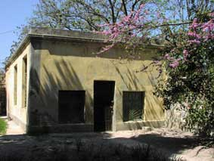  
  
*Epigraphic lapidarium*

Translation by © N. Khrapunov.

**Collections**

|  |  |
| --- | --- |
| Numismatics (under construction) [Epigraphy](http://www.chersonesos.org/?p=museum_coll_ep&l=eng)  Architectural details (under construction)  [Sculpture](http://www.chersonesos.org/?p=museum_coll_scp&l=eng)  Terra cotta ware (under construction)  Glazed ware (under construction)  Bone ware (under construction)  Lamps (under construction) |  |

Our museum basis consists of the artifacts discovered in course of archaeological excavations. The long [history of the investigations](http://www.chersonesos.org/?p=museum_hist&l=eng) in Chersonesos has collected more than two hundred thousand finds! You can view only a small part of them in the [museum displays](http://www.chersonesos.org/?p=museum_exh&l=eng); the rest are kept in the [storage](http://www.chersonesos.org/?p=park_otdfond&l=eng), and 'no trespassers are allowed to enter' there (and it is quite right!). And if you are a stranger, but a curious stranger? This Web page is at your service then. Here you can be acquainted with the collections of artifacts from Chersonesos in more details than in the museum display. We have decided that the most convenient way of discussing the finds if they are places in groups of the same general kind. So these pages have appeared.

**Sculpture Collection**  
  
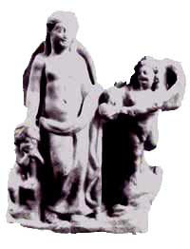

*Aphrodite with two Erotes*

Many-years-long archaeological excavations on the territory of the ancient Chersonesos and its agricultural environs discovered more than 650 monuments of statuary. At present, the most part of these artifacts is kept in the National Preserve of Tauric Chersonesos, though few isolated finds are in the largest museums of Ukraine (in Odessa Archaeological Museum) and Russia (in State Hermitage Museum in Saint-Petersburg and State Historical Museum in Moscow).Unfortunately, some monuments are lost now.

|  |  |  |
| --- | --- | --- |
|  |  | The history of scholarly studies in Chersonesos explains why its collection of sculptures is disordered and many fine pieces from this collection are lost. The thing is that the first excavations of this ancient city were made as early as 1827, when there was no museum in Chersonesos, and the finds, including sculptures, scattered through the museums of the Russian empire. Such a situation existed till 1892, when Karl Kostsyushko-Valyuzhinich's enthusiasm created "Warehouse of local antiquities", the prototype of the present museum. |

|  |  |
| --- | --- |
| But even then, the most interesting finds that certainly included statuary were exported to Hermitage museum because, from 1888, excavations of Chersonesos were funded by the Imperial Archaeological Commission. |  |

The evacuation of the museum to Kharkov in the years of the First World War did not come without losses. Yet the museum collection suffered a lot in the years of the Second World War. Although the best exhibits from the show rooms and museum storage were evacuated to Sverdlovsk in Ural region (now Yekaterinburg), a part of the monuments, which had been left at place, were never found later on. It was 1925 when Konstantin Grinevich supervised over the creation of the first scholarly museum exposition, which included monuments of statuary side by side with other artifacts.

|  |  |
| --- | --- |
| It was 1958 when Chersonesos museum started the organization of a special storage, lapidarium of statuary, for which more than 200 monuments were selected from the main storage. At that time, it was planned to make a permanent museum display in the lapidarium and to arrange this display according to historical method, with singling out different groups and categories of statuary. Unfortunately, the above task has not been solved completely to these days. At present, the collection of sculpture in the National Preserve of Tauric Chersonesos has about 600 pieces and is enlarged with new specimens almost annually, which is why it is impossible to locate all these monuments, according to their groups and categories, because of a very small area of the premise selected for the lapidarium of statuary. |  |

Chersonesos collection of sculptures includes the categories of monuments as below:   
-   statues, statuettes, and relieves of mythological figures of Greek and Roman pantheons;   
-   portrait sculpture;   
-   funeral monuments of various styles (classical, shaped like high narrow steles; anthropomorphic; with draped figures; with scenes of funeral repast; with half-length image of a man; showing veiled woman; of Roman soldiers, 'barbarian', and others);   
-   fragments of sarcophagi;   
-   decorative statuary;   
-   altars;   
-   early Christian statuary.

|  |  |  |
| --- | --- | --- |
|  |  | Chersonesos collection's distinctive feature is almost absence of complete, not fragmented, sculptures. Statuary group of Aphrodite with two Erotes, which was found in 1978 in the Gerakleyskiy peninsula, is perhaps the only intact monument among the statuettes. Some pieces of gravestones and separate relieves preserved better, but these constitute a very small percentage of the whole parcel of sculpture wares. |

|  |  |
| --- | --- |
| This situation might be caused by the circumstance that the citizens of Chersonesos must destroy images of pagan gods and heroes in the period when Christianity was being introduced as a state religion. It is very difficult to establish the chronology of the monuments of statuary because they are broken into smallest fragments, but one can be convinced that the most part of the collection is the first centuries A. D. copies, though the originals were made in classical and Hellenistic periods. |  |

It is hard to infer how much were there the number of pieces of high artistic quality in Chersonesos basing on the small fragments only. At any rate, Chersonesos developed a good taste and a high requirements for the works of art, as it can be seen from the monuments like Caryatid head, Aphrodite torso, head of a young athlete of the school of Skopas (they all are displayed in [Ancient Exhibition Hall](http://www.chersonesos.org/?p=museum_exh_ant&l=eng)), woman head, statuette of Eros (both fragments are in the statuary lapidarium) and some other monuments.

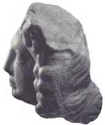

**EPIGRAPHY**

[Decree honoring Diophantos](http://www.chersonesos.org/?p=museum_coll_ep1&l=eng)   
  
[Inscription honoring the emperor Zeno](http://www.chersonesos.org/?p=museum_coll_ep2&l=eng)   
  
[Civic Oath of Chersonesos](http://www.chersonesos.org/?p=museum_coll_ep3&l=eng)   
  
[Decree honoring Syriskos the historian](http://www.chersonesos.org/?p=museum_coll_ep4&l=eng)   
  
[Base of statue for Agasikles](http://www.chersonesos.org/?p=museum_coll_ep5&l=eng)   
  
[Proxeny decree for an ambassador from Mithridates Eupator](http://www.chersonesos.org/?p=museum_coll_ep6&l=eng)   
  
[Decree honoring ambassadors from Herakleia](http://www.chersonesos.org/?p=museum_coll_ep7&l=eng)   
  
[Base of statue for Aristonos](http://www.chersonesos.org/?p=museum_coll_ep8&l=eng)   
  
[Treaty of alliance with the king Pharnakes I](http://www.chersonesos.org/?p=museum_coll_ep9&l=eng)   
  
[List of those who won sport competitions](http://www.chersonesos.org/?p=museum_coll_ep13&l=eng)   
  
[Inscription about the tax on prostitution](http://www.chersonesos.org/?p=museum_coll_ep14&l=eng)   
  
[Fragment of a decree about the fortress of Napites](http://www.chersonesos.org/?p=museum_coll_ep15&l=eng)   
  
[Inscription about construction of a city gate](http://www.chersonesos.org/?p=museum_coll_ep16&l=eng)   
  
[Dedication to the goddess Nemesis](http://www.chersonesos.org/?p=museum_coll_ep17&l=eng)   
  
[Inscription regarding the liberation of Kalos Limen](http://www.chersonesos.org/?p=museum_coll_ep18&l=eng)   
  
[Decree honoring the emperor Marcus Aurelius](http://www.chersonesos.org/?p=museum_coll_ep19&l=eng)   
  
[Decree honoring Gaius Julius Satyrus](http://www.chersonesos.org/?p=museum_coll_ep20&l=eng)   
  
[Proxeny for a citizen of Sinope](http://www.chersonesos.org/?p=museum_coll_ep21&l=eng)   
  
[Epitaph in verse on stele for Xanthos](http://www.chersonesos.org/?p=museum_coll_ep11&l=eng)   
  
[Inscription on the stele set up by doctor](http://www.chersonesos.org/?p=museum_coll_ep12&l=eng)   
  
[Epitaph in verse on stele for Oinanthe](http://www.chersonesos.org/?p=museum_coll_ep10&l=eng)

**Decree honoring Diophantos, strategos (general) of the Pontic king Mithridates VI**   
  
*Russian translation from the original ancient Greek by* [*V. V. Latyshev*](http://www.chersonesos.org/?p=excav_schol_prs_in10&l=eng)*, commentaries by* [*E. I. Solomonik*](http://www.chersonesos.org/?p=excav_schol_prs_in14&l=eng)  
  
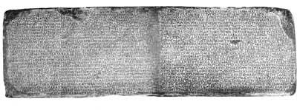

This marble base of a statue, which had been broken into two pieces, was discovered in 1878; in 1898, it was transported to the [Hermitage Museum](http://www.hermitage.ru/), St. Petersburg, that it has been being stored to these days. The monument dates to the late 2nd century B. C. According to the position of the feet, this decree was carved into the back side of the base and not on its front side as it has been supposed; and on the front side of the slab, which is missing now, there probably was a honorific inscription in the form like 'the council and the people to strategos Diophantos.'   
  
***The text of the inscription:***  
"(...) so-and-so and so-and-so son of Zethos proposed: whereas Diophantos, son of Asklapiodoros, of Sinope, being our friend and benefactor, and being trusted and honored second to none by the king Mithridates Eupator, has always been responsible for good for each of us, urging the king on to the most noble and glorious deeds; having been summoned by him and taking on the war against the Scythians, and arriving in our city, he courageously accomplished the crossing of the whole army to the opposite shore; and when Palakos, king of the Scythians, suddenly attacked him with a great throng, he (Diophantos), drawing his army up in the moment of need and routing the Scythians, who were thought to be irresistible, brought it about that the king Mithridates Eupator set up his first trophy from Scythian spoils; and rendering the neighboring Taurians subject to him and establishing a city in the place, he moved off into the Bosporian regions and, having in a short time carried out many great actions, he turned back into our regions again and, taking with him those citizens in their prime, he advanced into the middle of Scythia, and when the Scythians surrendered to him the royal fortresses of Chabaioi and Neapolis, it came to pass that almost all of them became subject to the king Mithridates Eupator, for which the grateful people honored him with the appropriate honors, as having been released from the domination of the barbarians.  
  
When the Scythians made manifest their innate faithlessness and revolted from the king and changed the state of affairs, and when, for this reason, the king Mithridates Eupator again sent Diophantos out with an army, although the season was closing on winter, Diophantos, taking his own troops and the most able of the citizens, set out against the very palaces of the Scythians, but hindered by storms and turning back to the coastal area he took Kerkinitis and the Walls and set about besieging those who lived in Kalos Limen. When Palakos thought the occasion was to his advantage and was collecting all his own (forces), dragging along also the tribe of the Reuxinalians, the Parthenos, who ever stands over the Chersonesites and who on that occasion was with Diophantos, foretold the action that was about to happen by the signs that occurred in the sanctuary and inspired the whole army with courage and daring. After Diophantos drew up his forces wisely it came to pass that the victory went to the king Mithridates Eupator, a splendid one and worthy of being remembered forever: for of the (enemy's) infantry scarcely a one was saved, and of the cavalry not many escaped. Leaving no time for inactivity, (Diophantos) advanced with his army at the beginning of spring against Chabaioi and Neapolis with all gravity (...) escape, and the rest of the Scythians take counsel of (...).  
  
And after moving off into the Bosporan regions, he arranged things there well and to the advantage of the king Mithridates Eupator.  
  
When headed by Saumakos Scythians rebelled and killed the king of the Bosporus, Pairisadas, who had raised him (Diophantos? Mithridates?), and laid a plot against Diophantos, he escaped the danger and boarded the boat that had been sent to him by (our) citizens, and coming (to us) and encouraging the citizens, having as a zealous helper the king Mithridates Eupator who dispatched him, he arrived at the beginning of spring with his army and navy, and taking with him a specially picked group of citizens in three ships, he set out from our city and took Theodosia and Pantikapaion; and punishing those who were responsible for the revolt and capturing Saumakos, who was the murderer of the king Pairisadas, he sent him under arrest into the kingdom (of Mithridates), and (thus) he regained the power of the king Mithridates Eupator. Besides that, aiding the embassies dispatched by the people he shows himself kind and zealous for everything of benefit to the Chersonesites.  
  
So in order that the people may be seen to return fitting thanks to its benefactors, be it resolved by the council and the people to crown Diophantos son of Asklapiodoros with a golden wreath at the festival of the Parthenia at the procession, the symmnamones making the (following) proclamation: "The people crowns Diophantos son of Asklapiodoros, of Sinope, for his virtue and his goodwill toward itself;" and to set up a bronze statue of him in full armor on the acropolis by the altar of Parthenos and that of Chersonasos; and for the magistrates listed to look after these matters, that they may be done as quickly and as splendidly as possible; and to have this decree inscribed upon the base of the statue, and for the treasurers of the sacred funds to provide the expense arising in these connections.  
  
These things were resolved by the council and the people, on the 19th (day) of the month Dionysios, when Agelas the son of Lagorinos was the king, and Menis the son of Heraklios was proaisymnetes, and Damasikleios son of Athanaios was secretary". ***Commentary:***

This is the biggest inscription covering the events of the [late 2nd century](http://www.chersonesos.org/?p=history_ant&l=eng) BC. that happened to Chersonesos, the Scythian kingdom, and the Bosporan kingdom (in the east Crimea). This monument is used in each study of the history of the northern Black Sea area and is still a source of discussions and various interpretations, especially regarding the rebel of the Scythian Saumakos in Bosporos, his origins, social status, and aims and goals of his unrest.

The inscription describes the war of Diophantos with the Scythians in every detail, by its stages, and how did Chersonesos regain the lands that had been occupied by the Scythians in the 3rd and 2nd century B. C., namely [Kerkinitis](http://www.chersonesos.org/?p=out_ant_kirkin&l=eng), the other forts, and the regions in the western coast of the Crimea.

The king of Chersonesos in this inscription was an elective official who performed some religious ceremonies on behalf of the state. Therefore, this 'king' differs form the ones of Bosporos, Pontic and Scythian kingdoms where this term referred to monarchs. The king of Chersonesos was eponym of the year: that is to say, the year was called after the king who performed his duties in that period.

***Commentary***  
  
**Symmnamones** - the officials responsible for religious ceremonies and rewarding the citizens.   
  
**Aisymnetes** - the magistrates who in some Greek cities held the power of judges to regulate disputes and troubles, though in the other ones they were the members of community assembly. One such official gave his name to the month, so he became eponym. Menis the son of Heraklios, the proaisymnetes, or the chair of the board of aisymnetes, was the one who performed the duty of eponym in the given month.

Translation by © N. Khrapunov.

**Inscription honoring the emperor Zeno (A.D. 488)**  
  
*Originally published by* [*Latyshev*](http://www.chersonesos.org/?p=excav_schol_prs_in10&l=eng)*, commentary by* [*Alexander Berthier de Lagarde*](http://www.chersonesos.org/?p=excav_schol_prs_in9&l=eng)   
  
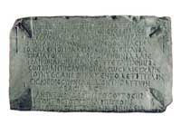

***Text:***   
  
"Autocrat caesar Zeno, pious, victor, trophy-winner, greatest, eternally reverend. His godliness was jealous of all cities and of this his city and donated money grants, namely those collected from the customs of local vicariate of devoted ballistarii. Renovating the walls at these (funds) to save this very city and flourishing, have we set up this inscription for eternal memory of his reign. This tower was renovated by labor of illustrious comes Diogenes, in the year of 512, indiction 11".   
  
***Commentary:***

[Under construction]

Translation by © N. Khrapunov.

***This is the most famous inscription of Chersonesos!***   
  
**Civic Oath of Chersonesos**

*Originally published by* [*V. V. Latyshev*](http://www.chersonesos.org/?p=excav_schol_prs_in10&l=eng)*, commentaries by* [*E. I. Solomonik*](http://www.chersonesos.org/?p=excav_schol_prs_in14&l=eng) *English translation by Thomas F. Lytle*   
  
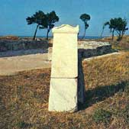

This white marble slab is decorated with cornice and pediment at the top. It was uncovered in the city main square, near the modern [St. Volodymyr's church](http://www.chersonesos.org/?p=ct_map21&l=eng), upper and lower fragments in 1890 and 1891 respectively, though another small fragment in 1899. The Oath was published and commented many times, both in Russian and foreign scholarship. The most part o scholars attribute it to the early 3rd century B. C.

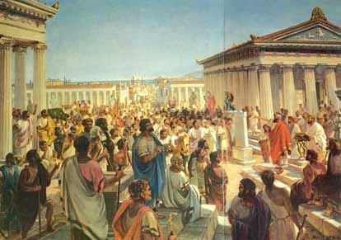  
  
*This picture shows the scene of taking the Oath in the ancient Chersonesos.  
Painting by R. Voskresenskiy*

***Text of the oath:***  
I swear by Zeus, Gaia, Helios, Parthenos, the Olympian gods and goddesses, and all the heroes who protect the polis, chora, and forts of the people of Chersonesos:  
  
I shall act in concord (with my fellow citizens) on behalf of the protection and freedom of the polis and its citizens.  
I shall not betray to anyone whomsoever, whether Greek or barbarian, Chersonesos, Kerkinitis, Kalos Limen, the other forts, and the rest of the chora, which the people of Chersonesos inhabit or inhabited. But I shall carefully guard all of these for the demos (the people) of Chersonesos.  
  
I shall not put down democracy. I shall neither rely upon nor help conceal either traitor or subverter, but I shall reveal them to the damiourgoi (magistrates) in the city.  
  
I shall oppose anyone who plots against, betrays or revolts from Chersonesos, Kerkinitis, Kalos Limen, the forts, and the chora of the people of Chersonesos.  
  
I shall hold the office of damiourgos; I shall be, to the best of my ability and with the greatest fairness, a councilor to the city and its citizens.  
  
I shall guard carefully the ΣÀΣÒÍÐÀ for the demos; and I shall not reveal to either a Hellene or barbarian any secret which is likely to harm the city.  
  
I shall neither offer nor accept a gift to harm the polis and its citizens.  
  
I shall not contrive with evil intention against any citizen who has not revolted (from Chersonesos); I shall neither rely upon one who plots (against the city) nor conceal anything from anyone, but I shall lay an impeachment and determine the matter by vote according to the laws.  
  
I shall pledge my oath to a conspiracy against neither the commonwealth of the people of Chersonesos nor any citizen who has not been shown to be an enemy of the demos.  
  
If I conspire with anyone and am bound by oath or solemn curse, may it be better for me and my possessions if I am reconciled (to the state), but the opposite if I stand fast (to the conspiracy).  
  
I shall report to the damiourgoi any conspiracy which I perceive to exist already or to be forming.  
  
Neither shall I sell grain suitable for exportation which comes from the plain, nor export grain from the plain to another place, except to Chersonesos.  
  
Zeus, Gaia, Helios, Parthenos, and the Olympian gods, as long as I abide by these covenants, may it be better for me, my family, and my possessions. But if I do not abide, may it be ill for me, my family, and my possessions; may neither the earth nor the sea bear their fruit for me; may the women not be happy in children ...

***Commentary***  
  
The Oath supplies evidences regarding [Chersonesos regime](http://www.chersonesos.org/?p=history_ant&l=eng), where the Council and the People's Assembly were the principle bodies of government, as well as where the frontiers of Chersonesos were located: at that time, this city-state included Chersonesos itself and also [Kerkinitis](http://www.chersonesos.org/?p=out_ant_kerkin&l=eng) (located at the place of present-day Yevpatoriya), [Kalos Limen](http://www.chersonesos.org/?p=out_ant_kalos&l=eng) (modern town of Chernomorskoye), several forts and lands in the west coast of the Crimea, and the close farming area ([chora](http://www.chersonesos.org/?p=chora&l=eng)) in the Gerakleyskiy (Russian for 'Herakleian') peninsula. The Oath, which really was something like a vow, mentions not only usual triad of deities (Zeus, Gaia, and Helios), but also the goddess Parthenos, the great protector of the city and the state. The order to bring the grain from the plain to Chersonesos only was extremely important for the economy of Chersonesos. The Oath was most probably introduced after an acute political struggle and restoration of democracy that had been temporarily lost. That was the reason why did the citizens swear to protect their democratic system from any infringement, to struggle against treasons, to serve the people faithfully, and to defend the frontiers from both Hellenes and barbarians. The meaning of the term ΣÀΣÒÍÐÀ ("*saster*") remains unclear.

**Damiourgos** – (or demiurge, as we now pronounce it) was an official of a high rank. Its position within the structure of the government of Chersonesos is not quite clear, the same as its functions, though it is evident that it was a political type office.

Translation by © N. Khrapunov.

|  |  |  |  |
| --- | --- | --- | --- |
| **Decree honoring Syriskos the historian**  *Originally published by* [*Latyshev*](http://www.chersonesos.org/?p=excav_schol_prs_in10&l=eng)*, commentary by* [*Solomonik*](http://www.chersonesos.org/?p=excav_schol_prs_in14&l=eng)   |  |  |  | | --- | --- | --- | |  |  | Consists of three fragments of white marble slab. The top is decorated by pediment with image of laurel wreath. It is not known where and when was this inscription found. It was published in 1881, by V.N.Yurgevich, in the 12th volume of "Zapiski Odesskogo obshchestva istorii i drevnostey." The other fragments were found in 1908 in the north-eastern area of the ancient city.  The monument dates to the second half of the 3d century B.C. |   ***Text:***   "Herakleidas son of Parmenontos proposed: whereas Syriskos son of Herakleidas, having diligently described the appearances of Parthenos, read (the above), and about the relations towards the kings of Bosporos told, and the relations with the cities that were peaceful investigated according to the people's dignity, so in order to do him appropriate honors, be it resolved by the council and the people to praise him for that, and for the symmnamones to crown him with a golden wreath at the 21th day of Dionysia, and to make the (following) proclamation:  «The people crowns Syriskos son of Herakleidas for he described the appearances of Parthenos and the relations with the cities and the kings that were peaceful investigated truly and according to the state's dignity;" for the symmnamones to write this people's resolution on a stone slab and set up in the narthex of the temple of Parthenos; and for the treasurer of the sacred funds to provide the expense arising in these connections. These things were resolved by the council and the people, on the tenth day of the month (...)»"   ***Commentary:***  This inscriptions mentions the most ancient historian Syriskos who described "the appearances of Parthenos", barbarians' attacks and other dangerous events from which Parthenos had saved her city, as well as the relations between Chersonesos and Bosporan kingdom and other states. For his historical works, which unfortunately did not preserve to these days, Syriskos was awarded with a golden wreath during festival of Dionysia. Similarly to Herodotus, he read his histories in public, probably in the [theater](http://www.chersonesos.org/?p=ct_map31&l=eng), which existed in Chersonesos as early as the mid-3rd century B.C. Mentioned by the inscription **symmnamones were the officials responsible for religious ceremonies and giving awards to the citizens.**  **Translation by © N. Khrapunov.** |

**Base of statue for Agasikles** *published by* [*Vasiliy Vasil'yevich Latyshev*](http://www.chersonesos.org/?p=excav_schol_prs_in10&l=eng)*, commentary by* [*Ella Isaakovna Solomonik*](http://www.chersonesos.org/?p=excav_schol_prs_in14&l=eng)   
  
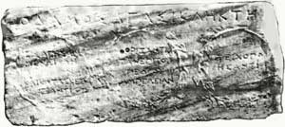

This base of statue is made of white marble and dates to the 3rd century BC. According to [Pavel Sumarakov's](http://www.chersonesos.org/?p=museum_hist&l=eng) information, it was discovered in 1794 and then transported to Odessa. After the Second World War, the stone was handed to the museum of Chersonesos, where it is stored at this moment. There are eight inscriptions carved in its sides and encircled by relief ivy and laurel wreathes. Some of the inscriptions are greatly damaged.   
  
***Text:***   
  
«The people (set up the statue of) Agasikles, son of Ktesios.  
  
*(in the wreathes:)*  
  
Who proposed the decree of the garrison and organized it.  
  
Who delimitated (or planted) vineyard in the plain.  
  
Who was a wall-builder.  
  
Who organized (?) the marketplace.  
  
Who was a strategos.  
  
Who was a priest.  
  
Who was a gymnasiarchos.  
  
Who was an agoranomos».  
  
***Commentary:***

This Agasikles was awarded with highest honors undoubtedly because he was a great public figure in Chersonesos: he was elected to important state posts and provided several measures to improve the [chora](http://www.chersonesos.org/?p=chora&l=eng) and the city and to strengthen the defense of the latter.   
  
**Strategos** - meant "general", who was usually elected annually to command the army (militia).  
  
**Gymnasiarchos** - was one of the most honorable offices in Greek city-states. Gymnasiarchos was responsible for training and teaching the youth and sport competitions organization. No public funds were granted for these purposes, so rich people were usually elected gymnasiarchoi.  
  
**Agoranomoi** - were those who controlled the marketplace. Their duties included the establishment and controlling the order of the trading places, and perhaps the price controlling of certain commodities; they also had the lists of all craftsmen in the city. This was an elective office.

Translation by © N. Khrapunov.

**Decree honoring the ambassador from the Pontic king Mithridates Eupator to Chersonesos**  
  
*Originally published, with the commentary, by* [*Solomonik*](http://www.chersonesos.org/?p=excav_schol_prs_in14&l=eng)

The three fragments of a marble slab were discovered in different areas of Chersonesos in 1891, 1913, and 1914.

The monument dates to the second half of the 2nd century B.C.  
  
***Text:***   
  
"Nomophilakes (...) and (...) who stands at the head of the government, proposed: whereas so-and-so son of Kephalas, of Amisos, being sent by the king Mithridates Eupator to our city as ambassador, displays himself well-disposed in every thing, arranges all the things related to his embassy in the best was, and makes his stay worthy and good for both the king and our people, be it resolved by the council and the people to praise him for this and give him and his heirs the proxeny, citizenship right, the right of entry and departure, without confiscation or treaty, for them themselves and their property; for the symmnamones to write this resolution on a white marble slab and set up in (...), and for the treasurers of the sacred funds to provide the expense arising in these connections. These things were resolved by the council and the people, on the ... (day) of the month (...)"  
  
***Commentary:***

This decree honored an unknown by name ambassador from the king Mithridates Eupator, who arrived to Chresonesos, with the aim to make negotiations with its citizens, shortly before the [wars of Diophantos](http://www.chersonesos.org/?l=eng&p=history_ant" \l "6), when the Pontic king Mithridates sent to the Crimea the army headed by his general Diophantos in order to help Chersonesos in its wars with the Scythian state and, simultaneously, to strengthen his own positions in the Crimea.

A person originated from Amisos, one of two capitals of the Pontic kingdom during the reign of Mithridates Eupator, stood at the head of the embassy. The cities of Amisos and Sinope housed the king's palaces, temples, and other structures. Many of Mithridates' most close collaborators, who held high positions in military or civil service, were born in these very cities. For example, general Diophantos originated from Sinope.  
  
**Amisos** was a city on the south Black Sea coast and one of the capitals of the Pontic kingdom.  
  
**Nomophylakes**, literally 'those who guard the law', were the officials responsible for keeping documents of state (laws), and supervised over the people's assemblies and meetings of the council. Their functions might also be similar with that of present court officers: British bailiffs and U.S. marshals.  
  
**Proxeny** was diplomatic relation of a special kind: the stranger was awarded, for his special merits, with certain honorable rights in the Geek polis (city-state), including the right of free-of-taxation trade, free entry and departure, etc. Proxenos was the one who represented officially the interests of another state and its citizens in his native state.  
  
**Symmnamones** were the officials responsible for religious ceremonies and giving awards to the citizens.

Translation by © N. Khrapunov.

**Decree honoring ambassadors from Herakleia to the Roman emperor**  
  
*Originally published by* [*Latyshev*](http://www.chersonesos.org/?p=excav_schol_prs_in10&l=eng)*, commentary by* [*Solomonik*](http://www.chersonesos.org/?p=excav_schol_prs_in14&l=eng)   
  
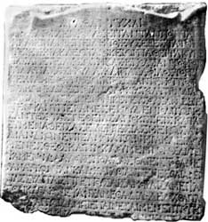

This marble slab was uncovered in 1893 near [Uvarov basilica](http://www.chersonesos.org/?p=ct_map27&l=eng) (its bottom is missing).

The monument dates to the period about the mid-2nd century A. D.  
  
***Text:***   
  
"Good fortune!  
  
Proedroi of the Chersonesites, who are in Taurica, proposed: whereas the most pious our fathers of Herakleia, with the kindred sympathy, rendering care for the sake of ours, applied every effort and all the true love and sent an embassy to our god and sovereign, emperor Titus Aelius Hadrian Antoninus to intercede for us, did not despise in anything, and made the divine answers and favorably given benefactions known through the most reverend men Herakleidos son of Menestheos and Proklos son of Memnon, for their honesty became evident, we have nation-widely acknowledged it necessary to render (them) befit recompenses. Therefore, be it resolved by the council and the people to praise for this our progenitor, the great city, and the first (...)".   
  
***Commentary:***

This is honorific decree for the ambassadors, who were sent by Heraklaia, metropolis of Chersonesos, to Rome, to the emperor Antoninus Pius (A. D. 138-161) asking for help for Chersonesos. Although centuries passed from the time when the colonists had left Herakleia to found Chersonesos, this decree called Herakleia the "progenitor city".  
  
**Proedroi** (literally "*those who seat in front*") were chairpersons in the council of the city community. One of the proedroi's duties was to propose projects of resolutions for the city and people's assembly.

Translation by © N. Khrapunov.

**Base of statue for Aristonos**  
  
*Originally published by* [*Latyshev*](http://www.chersonesos.org/?p=excav_schol_prs_in10&l=eng)*; commentary by* [*Solomonik*](http://www.chersonesos.org/?p=excav_schol_prs_in14&l=eng)   
  
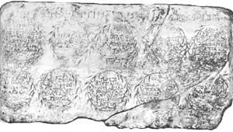

This marble statue base was found in 1881 in the area around the main city street and dated approximately to the mid-2nd century (A.D. 131 - 154).  
  
***Text:***   
  
"(Monument for) Aristonos son of Attinos, a friend of fatherland.  
  
Who had been an ambassador to divine Augustus (to petition) for freedom, for six years, and was exhausted.  
  
Who executed the office of prodikos.  
  
Who executed the office of nomophylax.  
  
Who executed the office of damiourgos beautifully.  
  
Who was an ambassador to the king Roemetalkes and was successful.  
  
Who executed the office of priest beautifully (and the people awarded him with a wreath) and copper image.  
  
Who managed the (state) treasury and elucidated the funds for the city.  
  
Who was an ambassador to the king Roemetalkes again and was successful.  
  
Who executed the office of damiourgos beautifully (and the people awarded him with a wreath) and a statue in full.  
  
Who was a beautiful citizen.  
  
- Ktesiphontos has executed"   
  
***Commentary:***   
  
This inscription honored Aristonos, who held several posts and successfully executed the city's commissions during the embassies to the Roman emperor Antoninus Pius and the Bosporan king Roemetalkes. The name of sculptor, Ktesiphontos, is indicated in the end of the inscription.   
  
**Damiourgos** was an official of a high rank. His position within the structure of the government of Chersonesos are not quite clear, the same as his functions, though it evidently was a political type office.  
  
**Nomophylakes** were the officials responsible for keeping documents of state and supervised over the people's assemblies and meetings of the council. Their functions might also be similar with that of present court officers: British bailiffs and U.S. marshals.  
  
**Prodikos** was a certain judicial officer, he might be a kind of arbitrator.

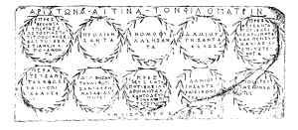  
  
*Line drawing of the inscriptions.*

Translation by © N. Khrapunov.

**The treaty of alliance between Chersonesos and Pharnakes I**  
  
*Originally published by* [*Latyshev*](http://www.chersonesos.org/?p=excav_schol_prs_in10&l=eng)*, commentary by* [*Solomonik*](http://www.chersonesos.org/?p=excav_schol_prs_in14&l=eng)*, translated by Burstein.*   
  
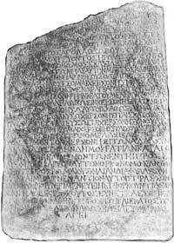

Marble slab (the top is broken). Found in 1908 in the north-eastern part of the ancient city, where it had been reused for the facing of a well.   
  
Dates to 179 BC.   
  
***Text:***   
  
"(...) but we shall attempt to preserve his kingdom to the best of our ability so long as he remains in friendship with us and preserves friendship with the Romans and does nothing against them. May all be well with us if we do not violate our oath and the opposite if we do. This oath was sworn on the fifteenth day of the month Herakleios when Apollodoros son of Herogeiton was king and Herodotos son of Herodotos secretary.  
  
The oath which king Pharnakes swore when Matris and Herakleios went on embassy to him:  
  
"I swear by Zeus, Gaia, Helios and all the Olympian gods and goddesses. I will be a friend of the Chersonesites for all time. If the neighboring barbarians march against Chersonesos or the territory ruled by the Chersonesites or injure the Chersonesites and they summon me, I will come to their aid if I can, and I will not plot against the Chersonesites nor will I do anything against the Chersonesites which might harm the Chersonesites, but I will attempt to preserve the democracy to the best of my ability so long as they remain in friendship with me and swear the same oath and preserve friendship with the Romans and do nothing against them. May all be well with me if I do not violate my oath and the opposite if I do.  
  
This oath was sworn in the one hundred fifty-seventh year, in the month Daisios, on king Pharnakes' year-count"   
  
***Commentary:***

In front of us is a treaty of mutual assistance and friendship between Chersonesos (the beginning of the oath of the Chersonesites is missing) and Pharnakes the king of Pontos.

The *king* of Chersonesos in this inscription was an elective official who performed some religious ceremonies on behalf of the state. Therefore, this 'king' differs form the one of Pontic kingdom, which latter term referred to a monarch. The king of Chersonesos was eponym of the year: that is to say, the year was called after the king who performed his duties in that period. Eponym of the month was the secretary, who performed his duties during this month. In the given case, secretary was the citizen of Chersonesos Herodotos son of Herodotos.

Translation by © N. Khrapunov.

**Fragment of a list of those who won sport competitions in Chersonesos**  
  
*Originally published by* [*Latyshev*](http://www.chersonesos.org/?p=excav_schol_prs_in10&l=eng)*; commentary by* [*Solomonik*](http://www.chersonesos.org/?p=excav_schol_prs_in14&l=eng)   
  
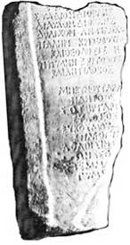

This fragment of a marble slab had been found in 1903 in the area around the [Reliquary Church](http://www.chersonesos.org/?p=ct_map36&l=eng), under which an ancient theater was uncovered in 1957; the inscription dates to the first centuries A. D.   
  
***Text:***   
  
"Race - Diokles (...)   
Double race - Diokles (...)   
Long-distance race - Antilochos (...)   
Wrestling - Kritoboulos ... and Theodosios (...)   
Fisticuffs - Kritoboulos (...) and Antilochos (...)"  
  
***Commentary:***

Above is a list of sports competitions which were held on a stadium: 1-stadium-long race (stadium was ancient Greek length unit equaling about 185 m), double-race, long-distance race, wrestling, and fisticuffs. Diokles was the one who won the first two competitions, Antilochos was the first in long-distance race, Kritoboulos and Theodosios got the best of in wrestling, though Kritoboulos and Antilochos, who participated in other competitions as well, were first in fisticuffs. Below, a verse of elegiac couplets honoring the main competitions victor is still visible.

Translation by © N. Khrapunov.

**Inscription about the tax on prostitution from Chersonesos**  
  
*Originally published by* [*Latyshev*](http://www.chersonesos.org/?p=excav_schol_prs_in10&l=eng)*; commentary by Svetlana Ivanovna Kurganova and* [*Solomonik*](http://www.chersonesos.org/?p=excav_schol_prs_in14&l=eng)   
  
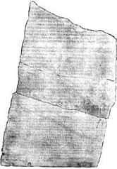

This slab of Prokonnesos marble was broken into five fragments; it was found in the southern area of the necropolis in 1891 and 1892. The inscription contains several documents being the correspondence between the governor of Moesia Inferior and the government of Chersonesos and the commanders of the Roman garrison which was stationed there. Three documents were written in Greek, one in Latin, and one is bilingual.

Text of the letter message is not supplied because this part of the inscription was considerably fragmented. The rest for the text is given with in Vasiliy Latyshev's reconstruction.   
  
***Text:***   
  
"II. Before, we (that is the Chersonesites) believed in king's rescripts, consulari's memoranda, and tribunes' court orders regarding (...) tax on prostitution and reckoned that we could be in a firm belief, taking into consideration that everything concerning our civil rights was confirmed by the divine (...) rescript of those who reign (that is Roman emperors) and secured the decision of those who judge, for our rights would not be violated in anything for the bad of all.

When those who are now in our garrison started violate so firm establishments and not only made some unjust and violent deeds in what was restricted for them but also dared to declare to you (the governor of Moesia Inferior), by a petition, their unjust claim, we sent you, our benefactor, a message asking to confirm the firmness of the rights, donated and condemned to us (...); it was not possible to make any delay of the message against those who accused us in order to stop those who are striving for the novelties, from their very beginning, by your benevolence. And in order to make investigation of this affair easier from the beginning and (...), we presented to you our petition to the kings and premised a copy of the rescript that was good for us, consulari's memoranda and tribune's order, because the case got, from the kings who donated, such a direction, being given to the tribune who was ordered to state a court order about it.

In this connection, we hope that you will become our patron, will guard what was stated with such a (...) and circumspection for it will have force in areas being subject to this tax, and will kindly accept the petition presented to you, as there is nothing more necessary for the people who understand the profit of prudent life and are striving for keeping decency (of manners).

III. What was sent by me (that is by the governor) to Atilius Primianus (the Roman tribune in Chersonesos) regarding the tax on prostitution, I ordered to be placed below looking after that neither you (that is the Chersonesites) would not be dejected in contrast to instructions, nor the officials would transgress the limit ordered.

IV. Letter copy. Which are the duties of the soldiers who compose Chersonesos vexillatio, regarding the tax on prostitution, will be shown by the attached copy of decision by Arrius Alcibiadis, who was, in those days, a tribune and commander of the same vexillatio, for the soldiers do nothing in defiance of both his opinion and clearly stated part that belongs to the court. And because it can not be imagined that the same Alcibiadis will accept the intention to raise the rate of the tax in the future and by his own will, as he stated his resolution already in a legal form (...) before, proposed and in all years brought the tax to treasury in the established amount, there is no doubt that this amount of the tax should be kept and held in accordance to discipline. Take care of a copy of his resolution should be written in a good script and be shown at (...), where it can be read correctly from a level place.

V. Letter copy. What was written by me to Atilius Primianus tribune (...) of collaborators' memorandum, which the same tribune sent to me, I attach here and order you to act, in all respects, according to the form of resolution stated by the former tribune Arrius Alcibiadis for they will not dare making something in contrast to discipline or violating the rights of or offending the local dwellers.

VI. Letter copy. What was written by me in response to the decree from the Chersonesites with their complaint against soldiers, and was ordered to be attached here, I remind anew: take notice that they, with a pretext of (...) will not raise the rate of the tax which was established and confirmed before, for the bad of your authority, will not disturb the citizens, and will not dare introducing any novelty.

Set up (?) during the archontes headed by Markos Aurelios Basileidianos Alexandros.

Ambassadors were T(itus) Flaouios Aristonos and Oualerios Germanos."  
  
  
  
***Commentary:***

It is the case of tax from the houses of prostitution. This tax was collected by the Roman military administration, so a part of the tax was given to the city, and a part to the Roman garrison. The correspondence between Chersonesos and the governor of Moesia Inferior province appeared because the Chersonesites were not satisfied with the Romans' attempt to raise their part of the income voluntary.  
  
**Vexillatio** – refers to a Roman army detachment.  
  
**Consulari and tribunes** – were the officials in the Roman administration.  
  
**Archontes** - were elective members of the city government headed by the first archon.  
  
**Meosia inferior** - was the Roman province covering the area between Danube and the Balkans (from the late 1st century A. D.).

Translation by © N. Khrapunov.

**Fragment of a decree about the fortress of Napites**   
  
*Original publication and commentary by* [*Solomonik*](http://www.chersonesos.org/?p=excav_schol_prs_in14&l=eng)   
  
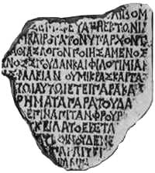

This fragment of a grayish marble slab was found in 1910 near Karantinnaya (Quarantine) bay and dated to the late 2nd century BC.  
  
***Text:***   
  
"(...) When the citizens were driven back by enemies and asked him to restore defensive walls on his own expense, (...) the most convenient, (...) displayed great firmness, celerity, and zeal for the people (...) safety (...). In the same year, calling for ( ... ), he collected the money from the people ( ... ) and advanced against the fortress of Napites (...). He promised that in the future would also act for the good of (...)"   
  
***Commentary:***

This inscription informs about the Scythian fortress of Napites that existed in the Crimea. This fort is not mentioned in the decree for Dipohantos neither in the Strabo's Geography. The person who was honored by the decree both provided his fellow citizens with money to fortify the system of defense of Chersonesos and himself took part in military operations aimed against the fortress of Napites.

Translation by © N. Khrapunov.

**Inscription about the building and repairing the city gates in 1059.**  
  
*Original publication and commentary by* [*Latyshev*](http://www.chersonesos.org/?p=excav_schol_prs_in10&l=eng)

***Text:***

"The iron gate of praitorion was constructed and the other (gates) of the city were renovated under Isaac Komnenos, great Roman king and autocrat, and Catherine, the most pious Augusta, by Leo Aliates, patrikios and strategos of Cherson and Sougdaia, in the month April, indiction 12 of the year of 6567".   
  
***Commentary:***

[Under construction]

**Isaac I Komnenos** - the Byzantine emperor (reigned in 1057-1059).  
  
**Year of 6567** of the Byzantine era (from the Creation) is A.D. 1059.  
  
**Praitorion** originally referred to general's tent in the Roman military camp, and in permanent camps it signified the commander's palace. In the Byzantine period this term acquired the meaning of the building where residence of the head of administration, strategos, as well as court of law and prison were located.  
  
**Patrikios** (Latin patricius, English patrician) was a Byzantine rank, which allowed the owner to possess the most important posts in state administration.  
  
**Strategos** was a governor of administrative unit and also of a city or fortress. In his province, he represented the power of the emperor, solved civil and military problems on behalf of the emperor's name, and was also a judge.   
  
**Sougdaia** was the name of present city of Sudak in the eastern Crimea.

Translation by © N. Khrapunov.

**Dedications to the goddess Nemesis**  
  
*Original publication and commentary by* [*Solomonik*](http://www.chersonesos.org/?p=excav_schol_prs_in14&l=eng)

**1.**

It is a small white marble altar with Greek inscription. It was discovered in 1964 in the area of the ancient theater and dated to the second half of the 2nd century A. D.

"Good fortune! Basileides son of Kalos (dedicated) to the goddess Nemesis."

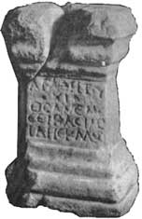

**2.**

This altar of local Sarmatian limestone with Latin inscription was found in 1957 during excavation of the ancient theater and dated to the 2nd or 3rd century A. D.

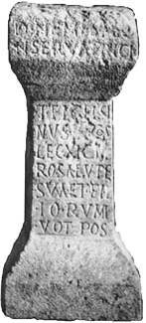

"To goddess Nemesis the Protector.   
  
Titus Flavius Celsinus, beneficiarius of consularis of the Eleventh Claudian legion, set up this by vow for the salvation of himself and children".  
  
***Commentary:***   
  
**Nemesis** - the goddess who personified destiny, determined retribution for people according to their gilt. In the imperial Rome, she was worshipped as patroness of gladiators and soldiers. Both Chersonesos altars were discovered in the area of the theater. Nemesis was the goddess of justice, so the Chersonesites might value this of her functions high, as their theater might possibly house people's assemblies and trials side by side with performances.   
  
Titus Flavius Celsinus was not an ordinary soldier but a **beneficiarius**. This was the name of a privileged category of soldiers, who were free from being on guard, digging, and foraging. Originally, beneficiarii were orderlies of province governors, and in the 2nd and 3rd centuries A. D. they became commanders of special type military posts both in and out camps, which were arranged throughout the Roman empire. When the Romans were establishing a new province, they, first of all, tried to arrange communications and built roads suitable for transportation of the army, equipment, and food between separate places where their troops were stationed. Within the camps, posts of beneficiarii were military offices though outside, on the crossroads, these posts provided secure traffic and were a chain that connected the camps. There, small sanctuaries were built to provide divine protection for the warriors in strange land. Archaeological investigations have discovered altars of beneficiarii, which are reliable milestones to reconstruct an elaborated system of Roman roads.

Translation by © N. Khrapunov.

**Inscription regarding the liberation of Kalos Limen**  
  
*Original publication and commentary by* [*Solomonik*](http://www.chersonesos.org/?p=excav_schol_prs_in14&l=eng)   
  
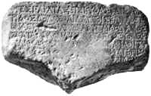

This fragment of white marble slab was discovered, by accident, in 1898 and dated to the late 2nd century B. C.   
  
***Commentary:***

This honorific decree is related to the events of the [wars of Diophantos](http://www.chersonesos.org/?l=eng&p=history_ant" \l "6). Although its text is considerably corrupted, one can infer that a certain troop of Chersonesos army liberated [Kalos Limen](http://www.chersonesos.org/?p=out_ant_kalos) (Greek for "Beautiful Harbor"), which had been occupied by the Scythians, and returned it under the power of Chersonesos state.

Translation by © N. Khrapunov

**Decree honoring the emperor Marcus Aurelius**  
  
*Originally published and commented by V. P. Yaylenko*

This marble slab with decree honoring the emperor Marcus Aurelius, procurator of the province of Moesia Inferior, Titus Aurelius Calpurnianus Apollonides and his wife Aurelia Paulina was found in 1990 in the area where the Roman citadel had been located. Fragments of this inscribed slab were used as a floor pavement in medieval tower.   
  
***Text:***

"(because)… stay at us… for good fortune, to honor him by the full complement of people's assembly, for which purpose to assemble the first citizens, demos, and the rest of population; to ask him (Apollonides) loudly… with exclusively joyful cry, to proclaim him altogether and solemnly the citizen, the councilor, and proedros; and to render him according to his deserts with every other honor (accepted by) us in response for his benefaction, as appropriate. Therefore, be it resolved by the council and the people. First of all, to praise the emperor for he sent such a procurator, the savior of the most beautiful region, support for the province; and also, to pay this (emperor) excellent honors to certify (that) he sent such a leader of piece for the good of our city. Then, to praise T(itus) Aurelius Calpurnianus Apollonides himself and render him with every honor and to set up his image and statues, and for the herald to make proclamation in the future times about his grace to us. To give him the proxenies, citizenship rights, (the right of) arrival and departure both in time of piece and war, without confiscation (or) treaty, for him and his heirs and his property. Will he be bouleutes, vote with the proedroi of the original Chersonesites, participate in all those affairs in the city in which the first of Chersonesos citizens participate. Will this resolution be carved in a white marble slab and set up in the most visible place of the city. These things were resolved by the council (and) the people in the year of 198 of Parthenos' reign, when Oulpios Bakchios was the priest, on the first day of the month Eukleios (March), when T(itus) Fl(avius) Attianos was secretary of the council. These things were authenticated by seals in the first (line): goddess queen Parthenos, Oulpios Bakchios priest, Themistos son of Straton first archon, Ariston son of Theagenes, Apollonides son of Hieronos, Stratokles son of Stratophilos, Peison son of Gaios, Kelerianos son of Stratophilos, Filomousos son of Philomousos, Chrestos son of Papios, Kyrenios son of Lysimachos, Antipatros son of Antipatros, Attinas son of Patros, Oualerios Preimanos, T(itus) Fl(avius) Ariston heir of Pontikos, Apollonios son of Apollonios, Arestion son of Theagenes. Second (line): Fl(avius) Nason second archon, Demoteles son of Demoteles, Attinas son of Eurydamos. Third (line): Ioulios Peison third archon, Attinas son of Ariston first prodikos, Eurydamos son of Diogenes. Fl(avius) Parthenokles nomophylax signed and the secretary of the council.

(...) - being from the people - gathered (equipped) - with us - as appropriate. Therefore, be it resolved by the council and the people to praise Aurelia Paulina wife of this city's benefactor T(itus) Aurelius Calpurnianus Apollonides, for all that, to crown (her) with a golden wreath from the council and the people's assembly, and to announce thanks from the people at the closing common festival. To give her the proxenies, citizenship rights, (the right of) arrival and departure both in time of piece and war, without confiscation (or) treaty, for her and her property, and participation in everything which is possessed by the Chersonesites. Will this resolution be carved in a white marble stele and set up in the most visible place of the city. These things were resolved by the council (and) the people in the year of 198 of Parthenos' reign, when Oulpios Bakchios was the priest, on the first day of the month Eukleios (March), when T(itus) Fl(avius) Attianos was secretary of the council".   
  
***Commentary:***

[Under construction]

**Archontes** were elective members of the city government headed by the first archon.   
  
**Nomophylakes**, literally 'those who guard the law', were the officials responsible for keeping documents of state (laws), and supervised over the people's assemblies and meetings of the council.  
  
**Prodikos** was a certain judicial officer, he might be a kind of arbitrator.

Translation by © N. Khrapunov.

**Decree honoring Gaius Julius Satyrus**  
  
*Description by* [*Solominik*](http://www.chersonesos.org/?p=excav_schol_prs_in14&l=eng)*, commentary by Mikhail Ivanovich Rostovtsev*   
  
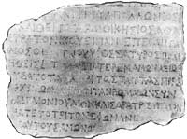

This fragment of white marble slab was found in 1911 in the north-east area of the ancient city and dated to 40s B.C.

It is the beginning of a honorific decree for Gaius Julius Satyrus who was sent in embassy to Gaius Julius Caesars in Rome. Misfortunately, one can only make hypotheses about the goals of his embassy, because they were stated lower, in the part of the slab which is missing now; these goals were most likely related to the ask of receiving 'free city' status for Chersonesos.   
  
***Commentary:***

[Under construction]

**Proxeny for a citizen of Sinope**  
  
*Late 2nd century BC. Originally published by* [*Latyshev*](http://www.chersonesos.org/?p=excav_schol_prs_in10&l=eng)

***Text:*** *"Nomophylakes Eukrates son of Prytanios, Pleistonax son of Dionysios, Apollonios son of Parthenokleios, and Apollodoros son of Herogeitos who stands at the head of the government, proposed: whereas Menophilos son of Menophilos, of Sinope, is a person good and honorable for the people of Chersonesos, and always nobly presenting himself at the disposal, particularly to the citizens who are dealing with him, and displayed himself good-willing and ready for help, trying always to do some benefit, so in order that the people may be seen worthy of the men, who are aspiring to get better benefits, be it resolved by the council and people (...)".****Commentary:***

*[Under construction]*

***Nomophylakes****, literally 'those who guard the law', were the officials responsible for keeping documents of state (laws), and supervised over the people's assemblies and meetings of the council. Their functions might also be similar with that of present court officers: British bailiffs and U.S. marshals.*

*Translation by © N. Khrapunov.*

**Epitaph in verse on stele for Xanthos**  
  
*Original publication by K. M. Kolobova*

|  |  |
| --- | --- |
|  | This marble stele is decorated by carved cornice and rosettes. The slab was reused because there are visible traces of an old inscription that was cut off from it.  It was discovered in 1892 in the necropolis at the southern defensive wall.  The monument dates to the first centuries A. D. |

***Text:***   
  
"Xanthos son of Lagoreinos, farewell!  
Stranger, I (the stele) am hiding Xanthos who was  
consolation to (his) father,  
young beauty of fatherland,  
adept in Muses secret, blameless amidst multitude of fellow citizens,  
honored amidst all the youth, bright star of beauty.  
In a battle for fatherland, he was ruined by envious Ares,  
having left a bitter gift of tears to poor parents.   
Oh, if Pluto receives more children for pleasure than you do,  
Why are you, wives, tortured in having a child?"  
  
  
***Commentary:***   
  
**Muses** were divine patronesses of arts.   
**Ares** was the god of war.   
**Pluto** was the divine owner of countless riches of the underworld.

Translation by © N. Khrapunov.

**Epitaph in verse on the stele set up by doctor**  
  
*Original publication and commentary by* [*Solomonik*](http://www.chersonesos.org/?p=excav_schol_prs_in14&l=eng)   
  
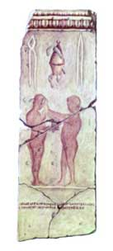

This limestone stele is broken into six fragments. Under the cornice, medical instruments are represented in paints: forceps, cupping glass, and pincers); below are two male figures, with inscription in verse under them. The monument was excavated in 1969 from the stonework of defensive walls.

Dated to the late 4th or early 3rd century B.C.   
  
***Text:***   
  
"This tomb honors Leschanoridas  
from Eukles, doctor, who gave birth to him, of Tenedos".   
  
  
  
***Commentary:***

In the same place, another stele was found, for a doctor, of the same period, with badly preserved image of medical instruments and short inscription under cornice: "Dionysios son of Pantagnotos".   
  
**Tenedos** is an island in the Aegean Sea, at the shores of Troad (at present it is a possession of Turkey).

Translation by © N. Khrapunov.

**Epitaph in verse on stele for Oinanthe**  
  
*Originally published by* [*Latyshev*](http://www.chersonesos.org/?p=excav_schol_prs_in10&l=eng)   
  
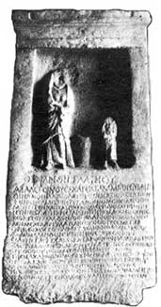

Marble gravestone. Two female figures are shown standing in the niche, their faces are chopped off, and between them is a basket for needlework. The monument was found in 1890 near Kazach'ya bay.   
  
Dates 2nd century A. D.   
  
***Òext:***   
  
"Oinanthe daughter of Glaukios.  
  
The Muses would better glorify your beauties, the ill-starred young wife Oinanthe, having your children placed at your knees, and (sing) the beauty law of the goddess Ilithia who helps in having a child, the joyful gifts for your mother, father, and husband. But now you are sleeping on cold sands near waves of murmuring Kokytos, and incessant sound of beloved voice, with which your mother, like a bird, is mourning for you, can not wake you; you hear nothing, like a stone, but black deep streams of the Ocean are flowing around you, and the souls of the dead coming under the earth are making terrible noise; you can not understand cry of your parents nor of your husband, as you drank - alas! - from Lethe's water. What a cruel law of the blissful! Aren't the young women who die early neither the bad nor originated from petty parents but those who have the most outstanding beauty or noblest origins? So not without reason said Pythoness to men a good proverb that every gold (that is beautiful) descendent was the first to come down to Hades".   
  
***Commentary:***   
  
This epitaph in verse mentions rivers **Kokytos** and **Lethe** in the underworld kingdom of Hades, as well as the **Ocean**.   
  
**Pythoness** was priestess and prophetess at Apollo temple at Delphi.

Translation by © N. Khrapunov.